

**Department of Computer Science**

**American International University-Bangladesh**



Course Name:  SOFTWARE REQUIREMENT ENGINEERING

“Assignment on Project Management Tool”

**Section:** B

**Supervised By:**

ABHIJIT BHOWMIK

Associate Professor & Special Assistant [OSA], Computer Science

**Submitted By:**

Partha Roy (20-43575-1)

Sumaiya Malik (20-43688-2)

Soily Ghosh Sneha (20-43702-2)

Submission Date: March 28,2023.

We used **ClickUp** tool for the Project Management.

Our project is based on Online laundry Service, that includes a website service for the customers convenience. Our service is designed to take the hassle out of doing laundry, making it easier and more efficient. The laundry service offers a wide range of options to meet the customer’s needs, including washing, drying, folding, and ironing. Our team of experienced professionals is dedicated to providing the highest quality service, ensuring that the clothes are handled with care and attention to detail. Our website service allows customers to easily schedule pickups and deliveries, track the laundry status, and make payments. The customers can customize the laundry preferences and receive notifications when their laundry is ready for pickup or delivery. We use the latest technology and equipment to ensure that laundry is done quickly and efficiently. Our facilities are equipped with state-of-the-art washers and dryers, and we use only the best quality detergents and fabric softeners to ensure that the clothes come out fresh, clean, and smelling great.

**Steps for Sign Up:**

**For Member 1:**

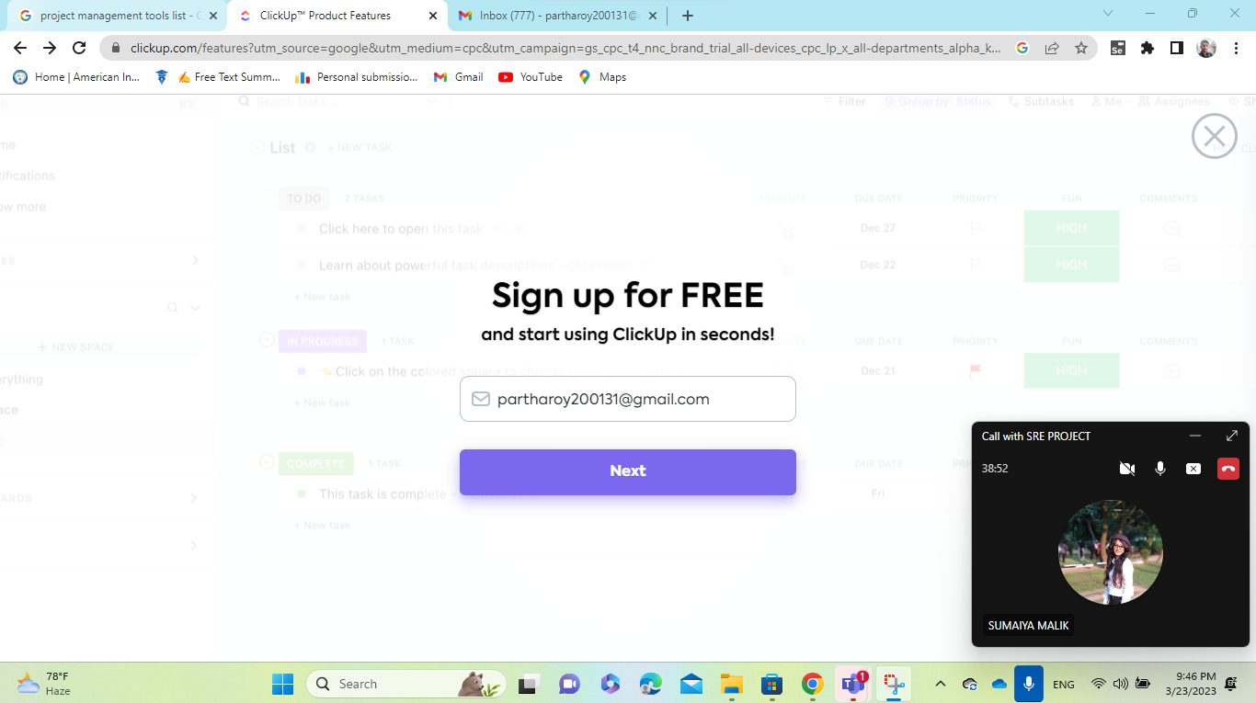

**Figure: Singing up with email.**

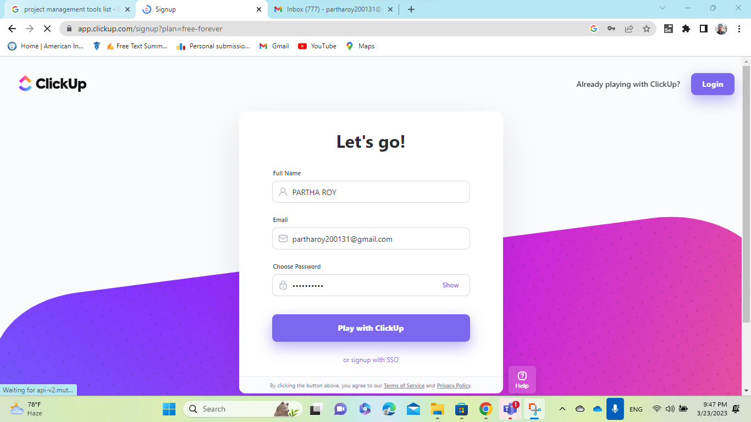

**Figure: Write Full Name, Password and login.**

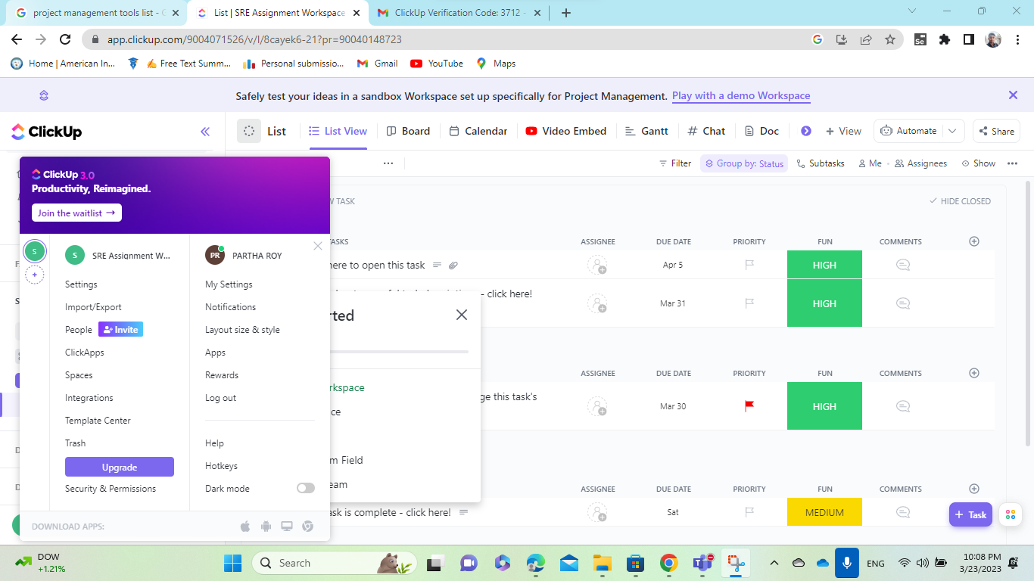

**Figure: Dashboard after the successful login and settings.**

**For Member 2:**

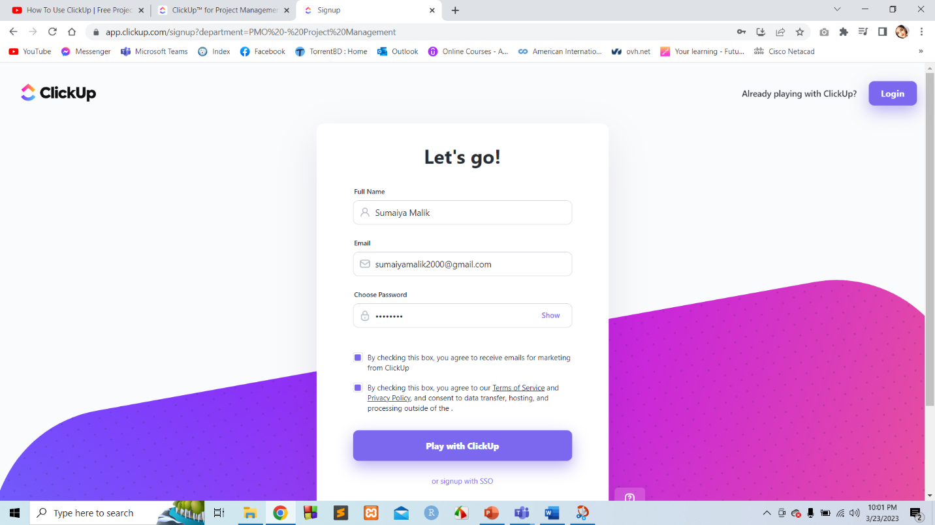

**Figure: Write Full Name, Password and login.**

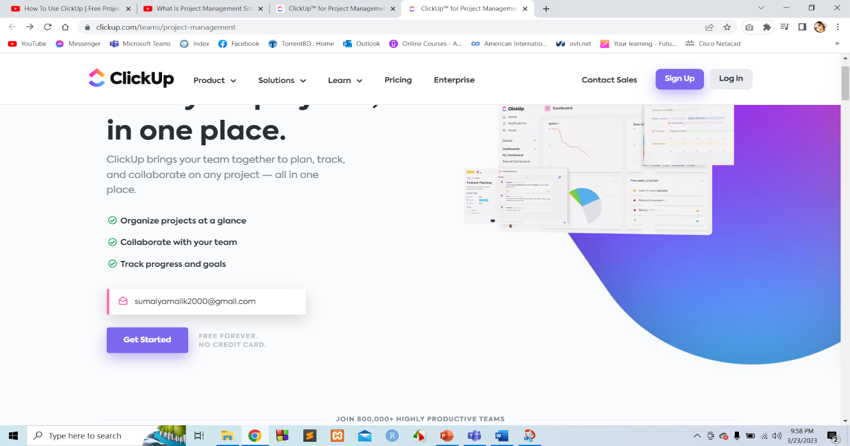

**Figure: Singing up with email.**

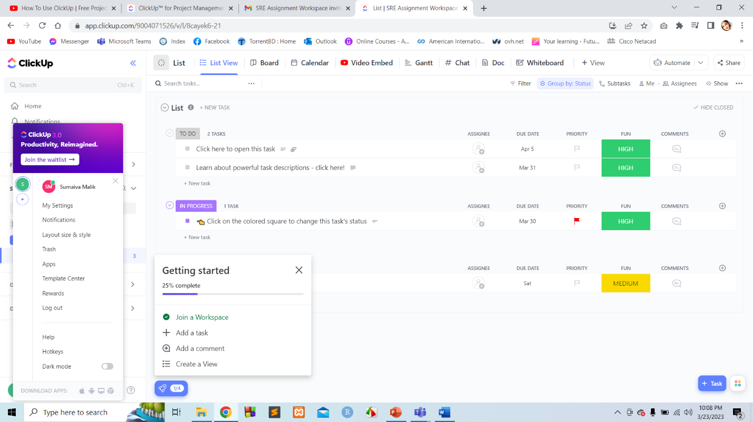

**Figure: Dashboard after joining the project via email invitation.**

**For Member 3:**

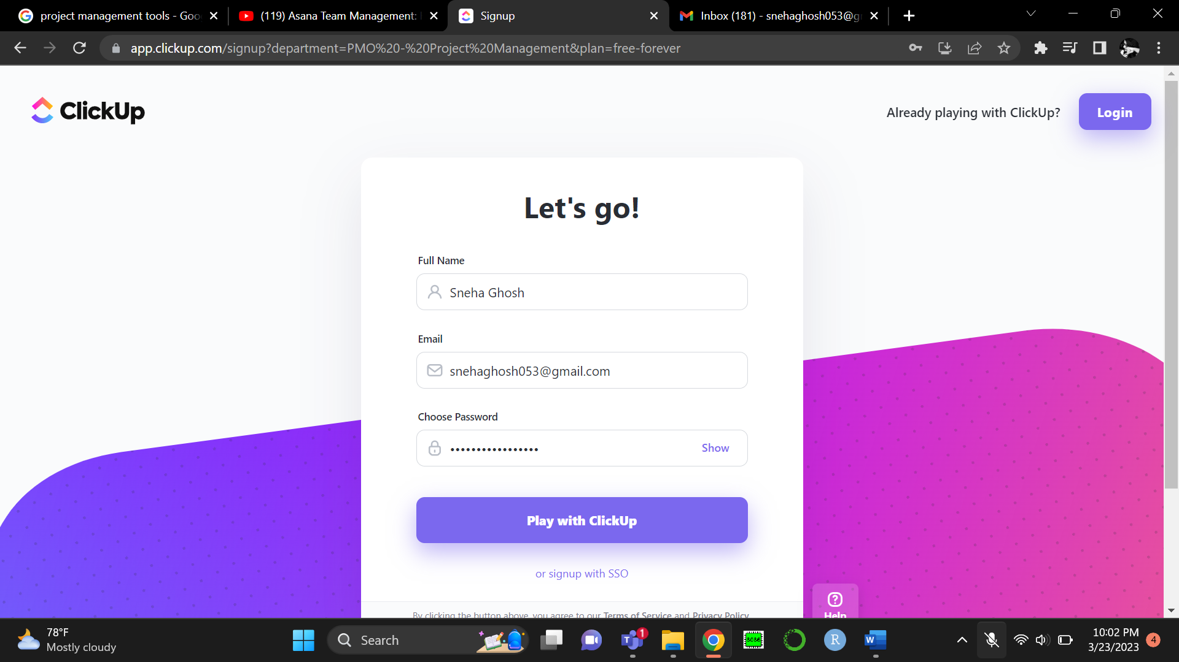

**Figure: Then write Full Name, Password and login.**

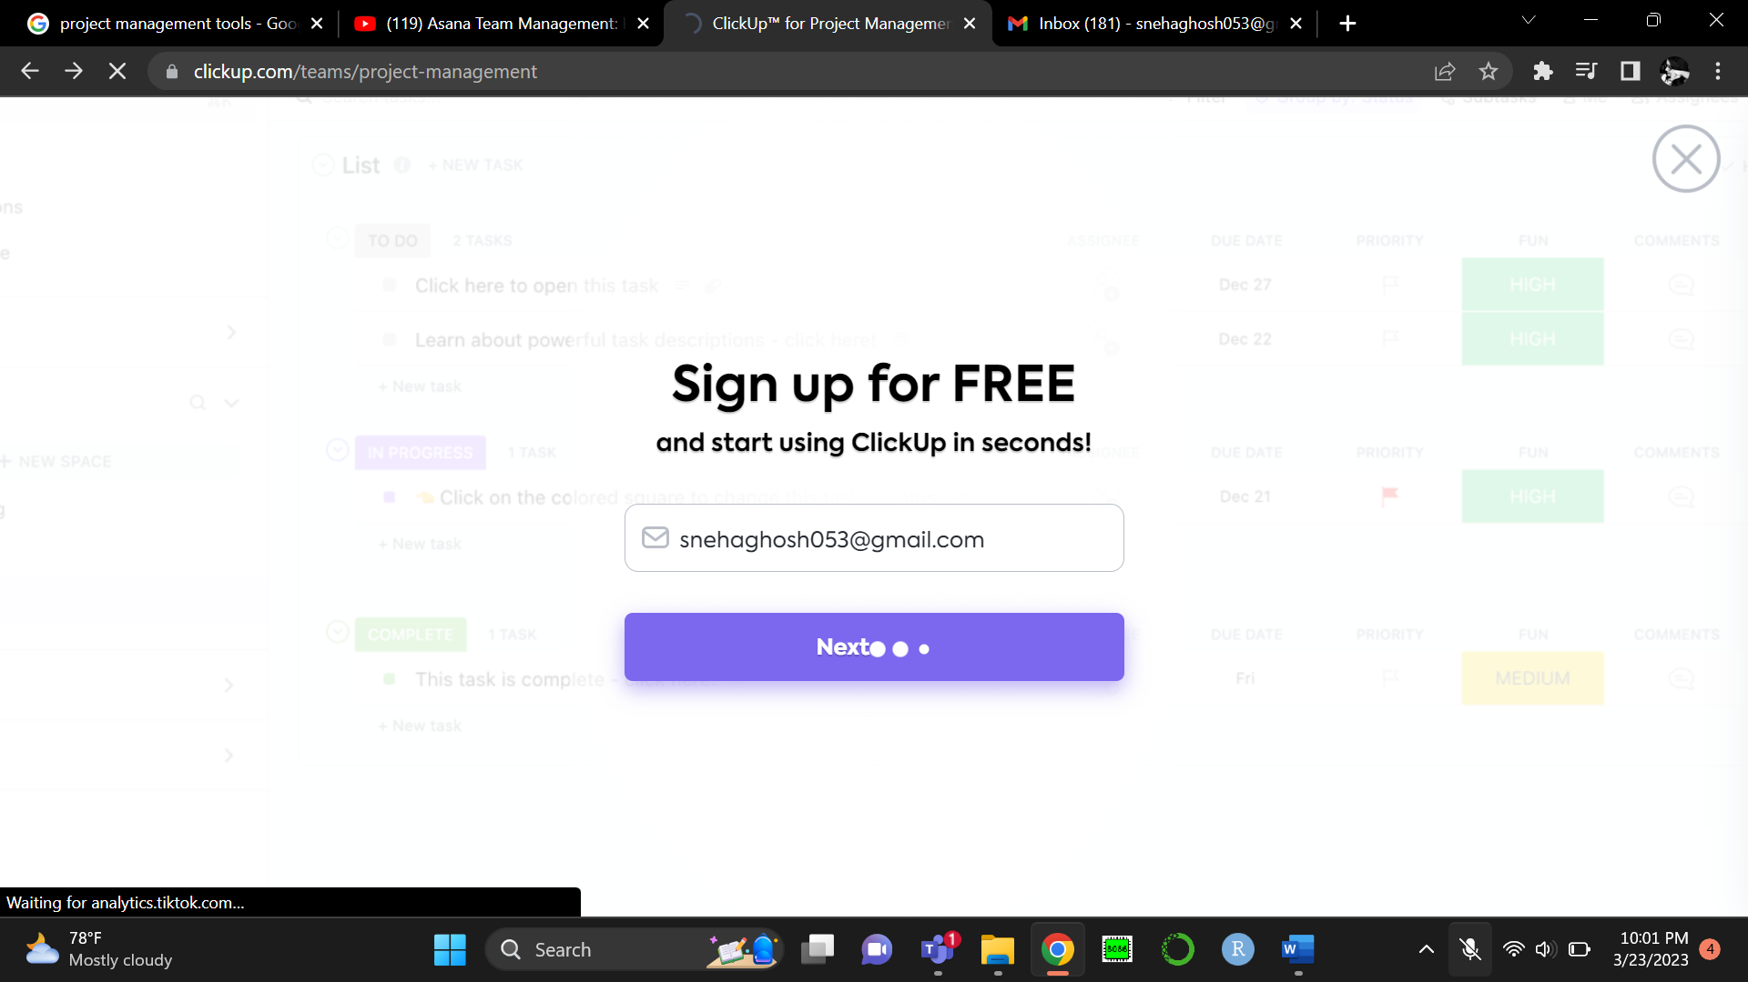

**Figure: Singing up with email.**

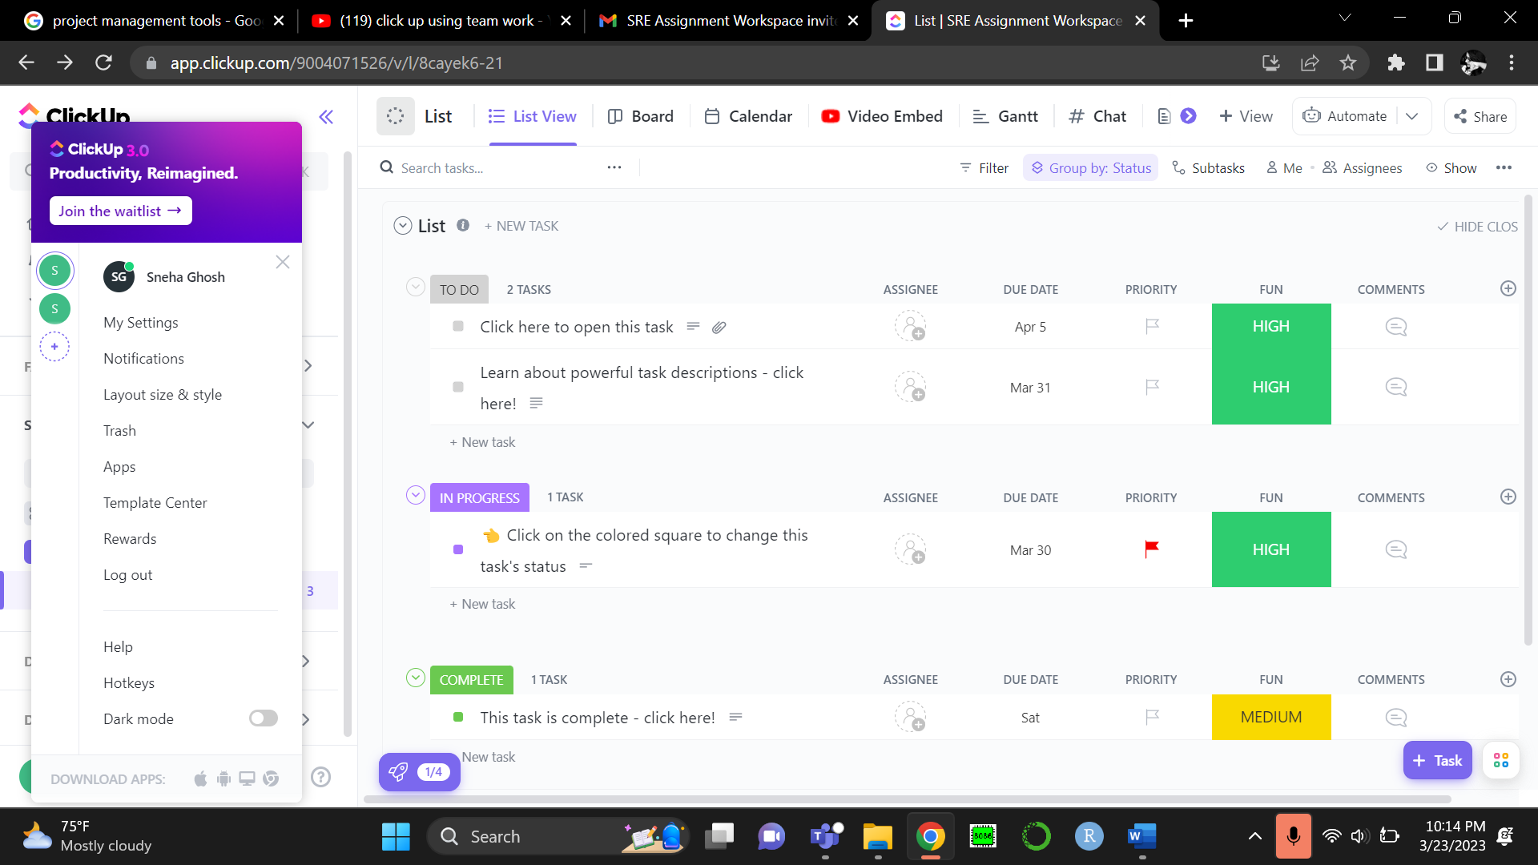

**Figure: Dashboard after joining the project via email invitation.**

**Step 2: Basic Settings after login the ClickUp**

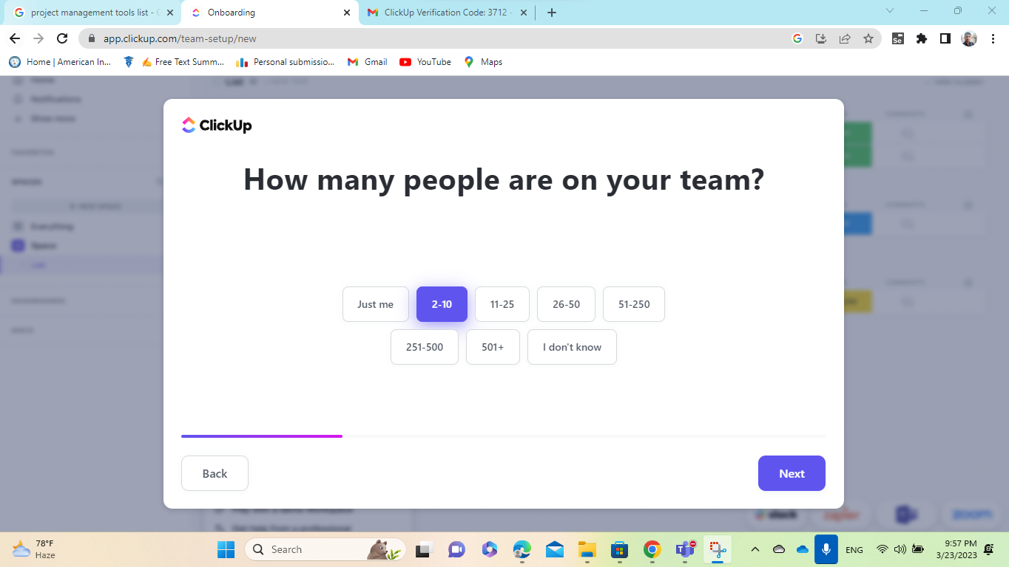

**Figure: Selecting number of team members for the project.**

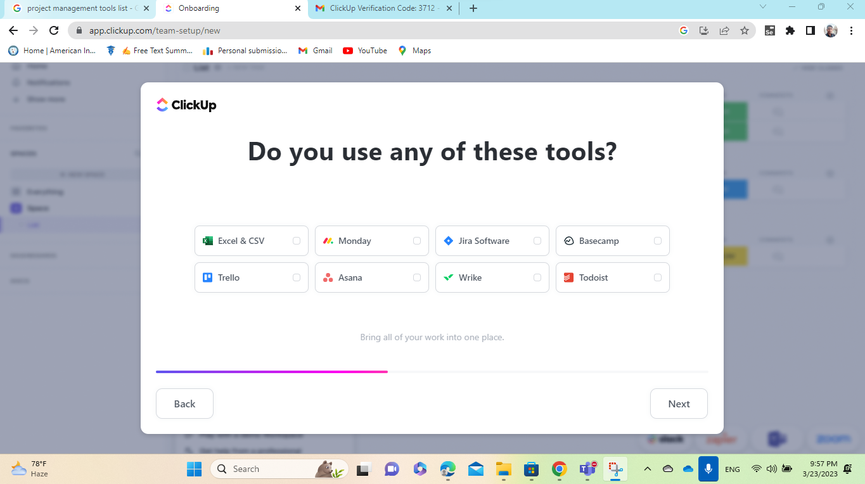

**Figure: Choosing tools.**

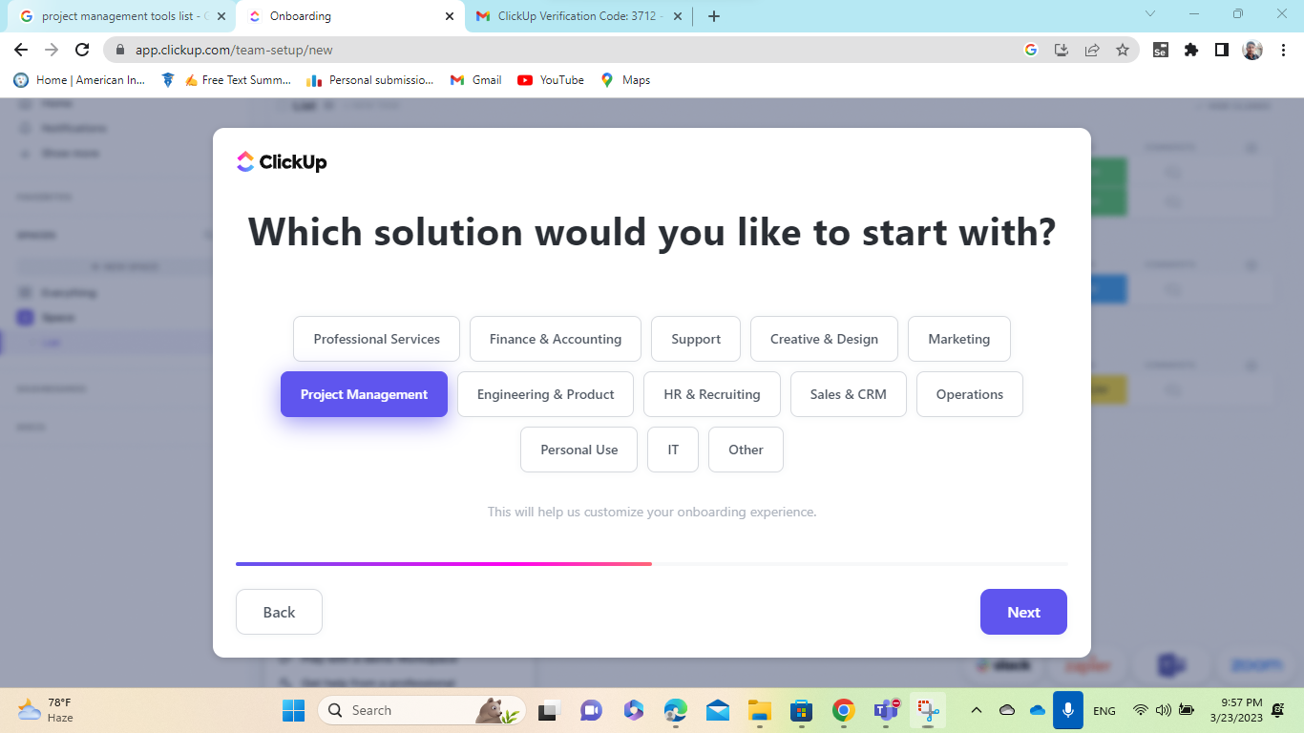

**Figure: Choosing the type of solution.**

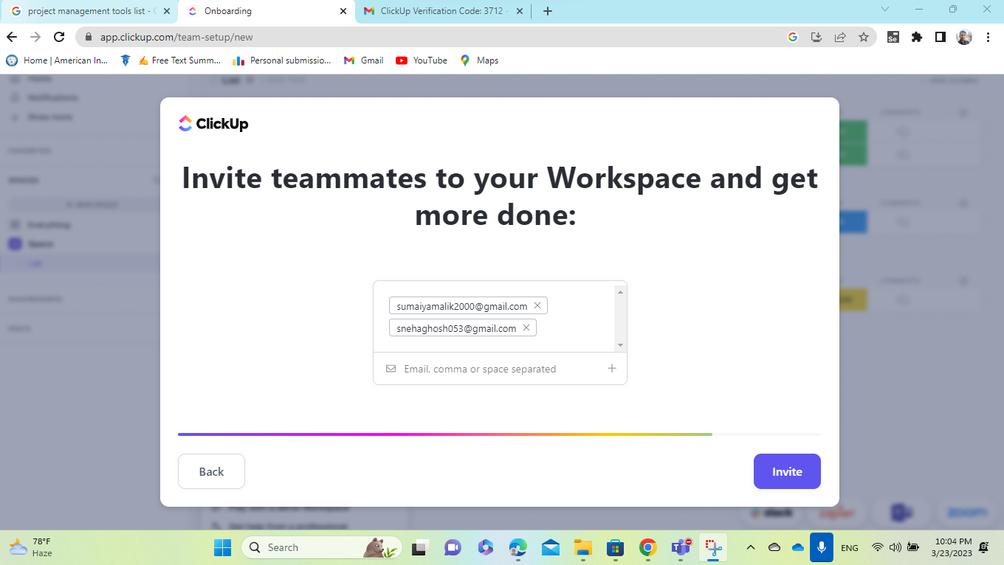

**Figure: Inviting team members for the project.**

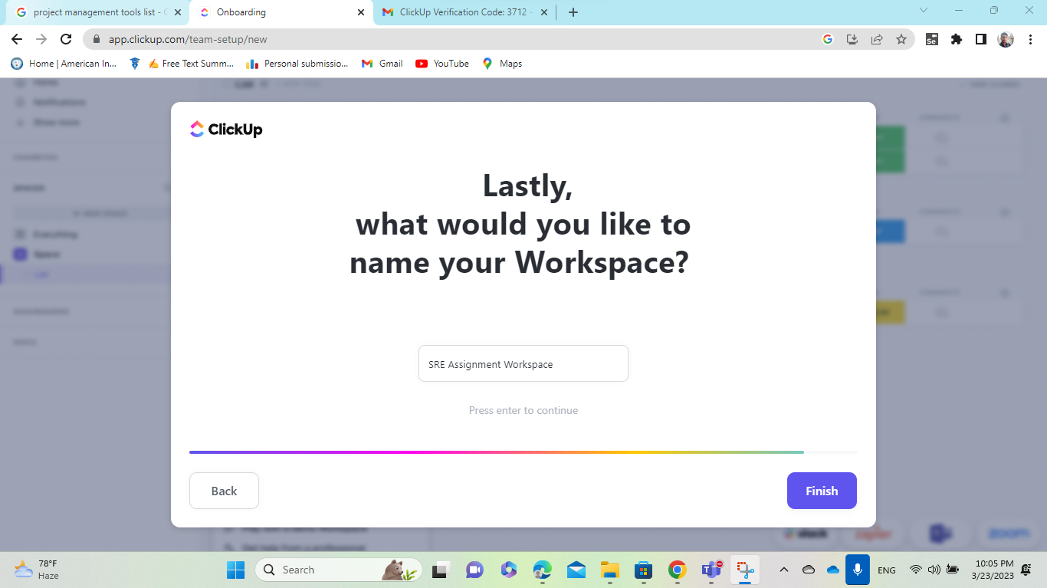

**Figure: Naming the Workspace as SRE Assignment.**

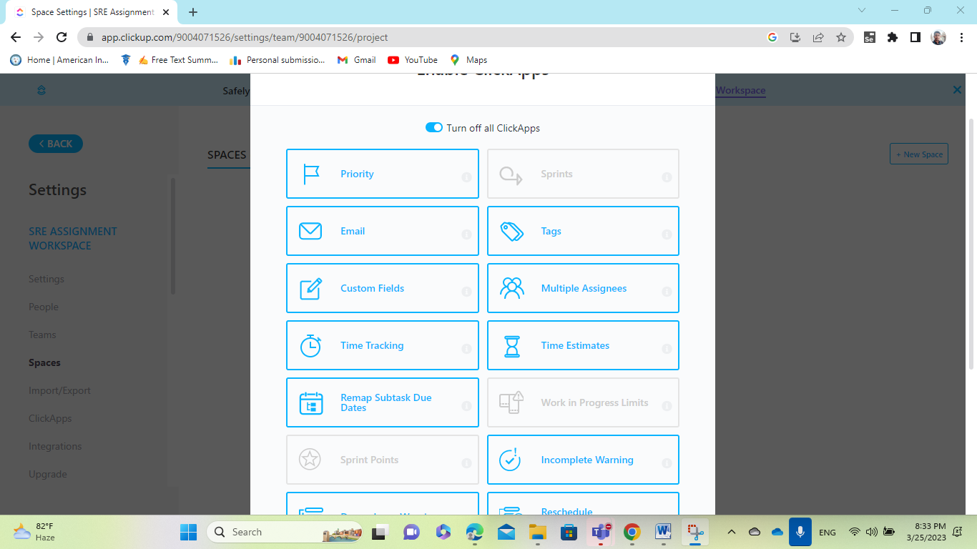

**Figure: Notifications Turned ON for the ClickApps.**

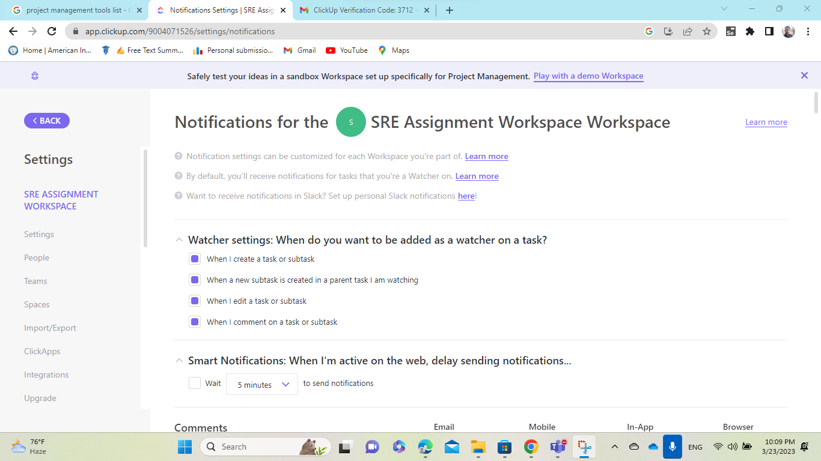

**Figure: Turned ON Notifications for the Workspace.**

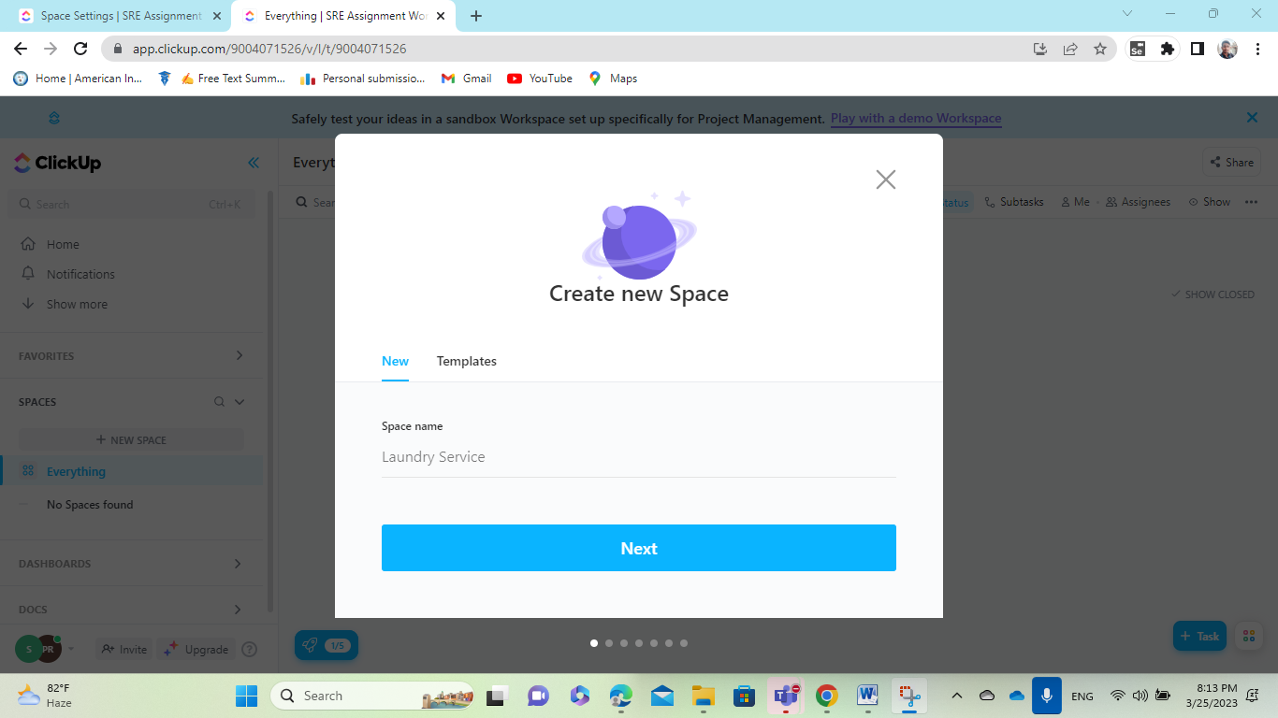

**Figure: Create a New Space.**

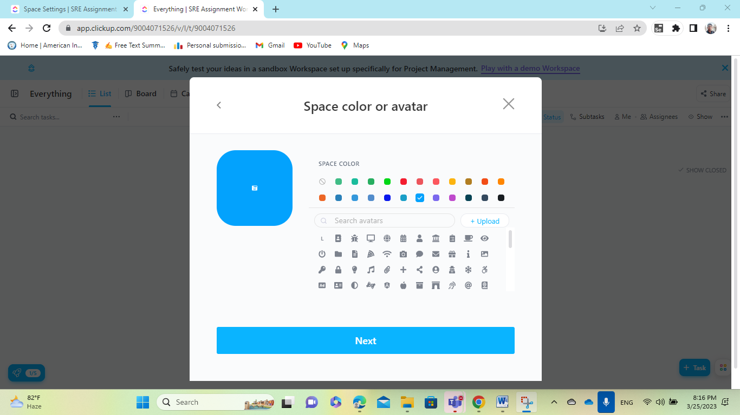

**Figure: Selecting a color and avatar for the space.**

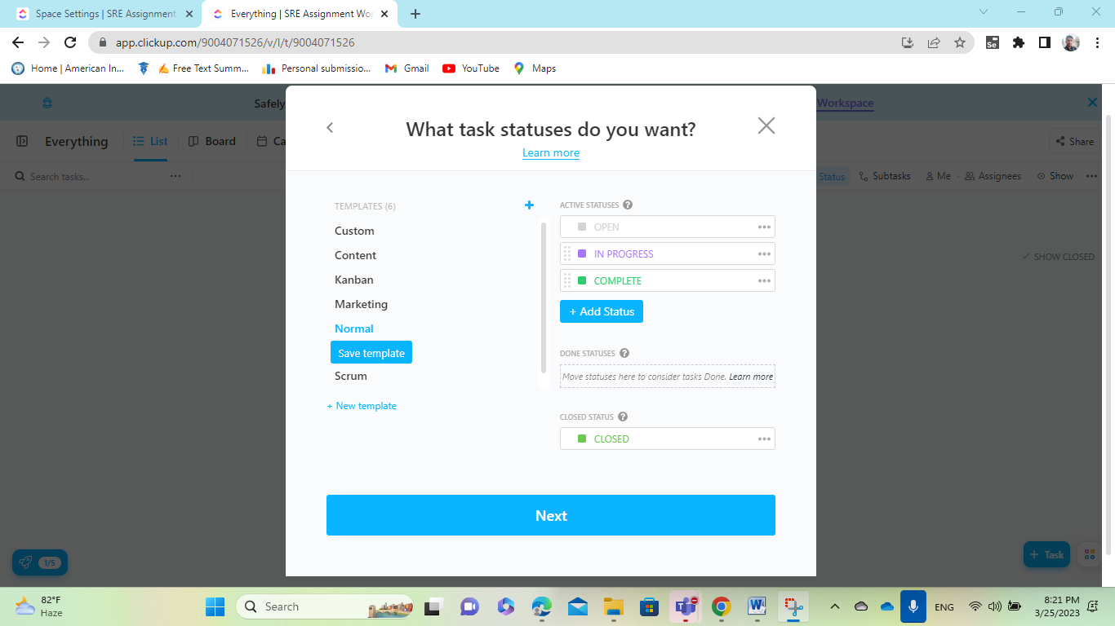

**Figure: Setting the Task Status we want to see in the Dashboard.**

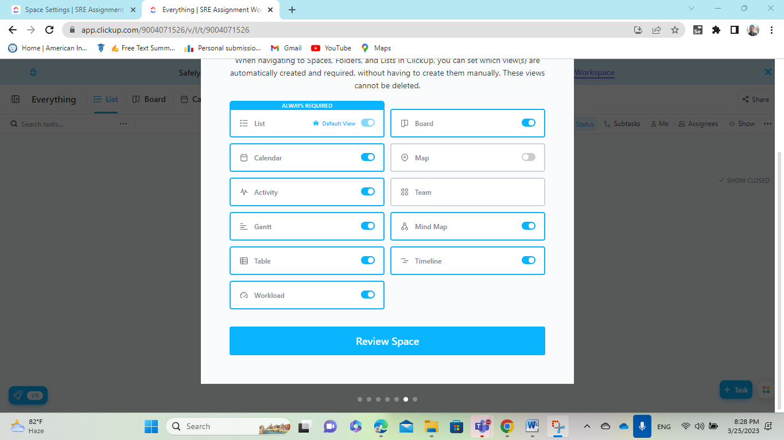

**Figure: Notifications Turned ON that will be displayed on the dashboard.**

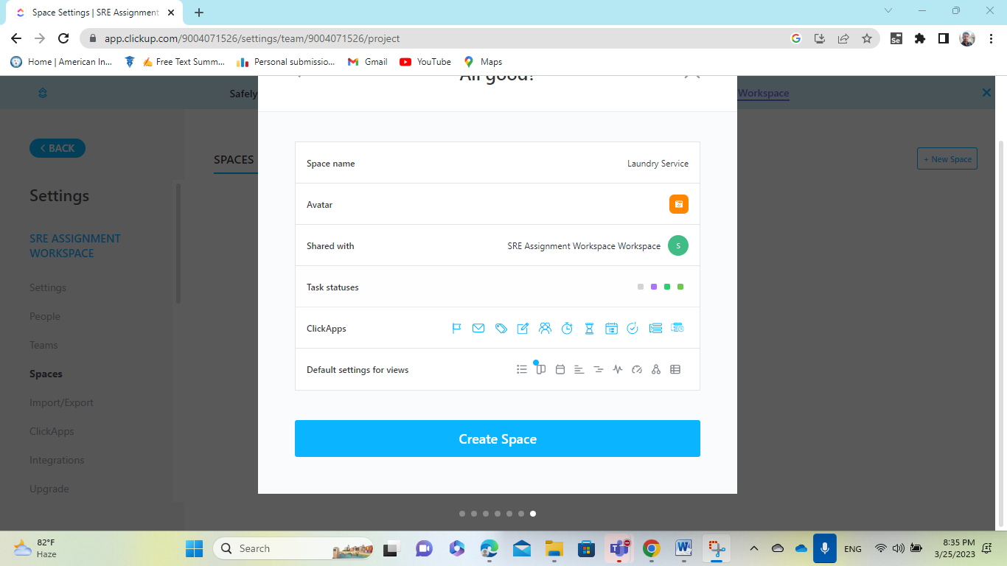

**Figure: Summary of setting for create Space.**

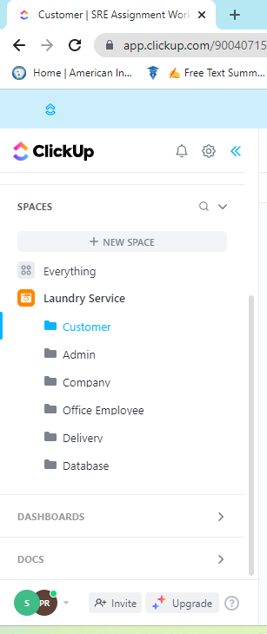

**Figure: Folders created under Space (Laundry Service).**

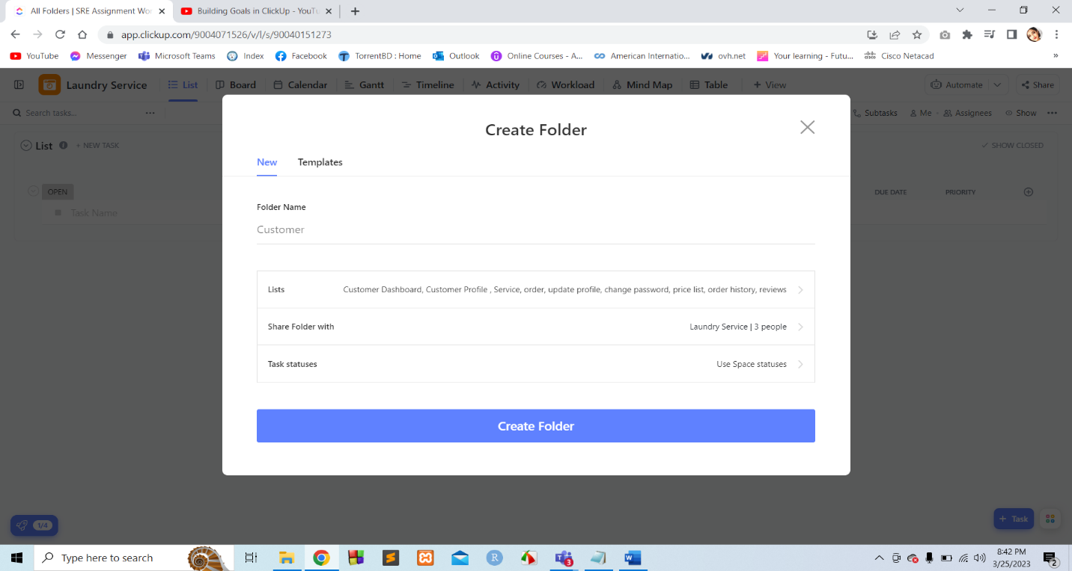

**Figure: Creating a Folder (Customer).**

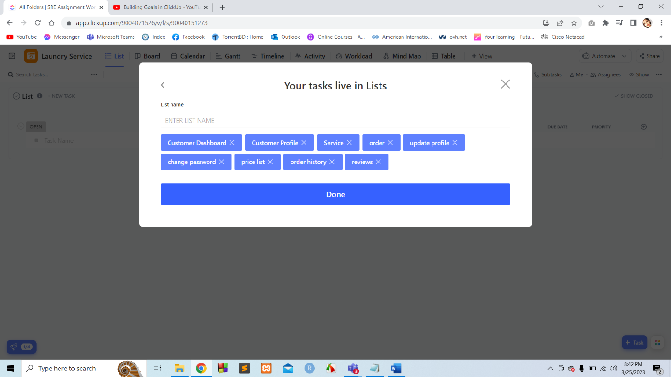

**Figure: Creating list under the page section in the folder.**

**Create Task:**

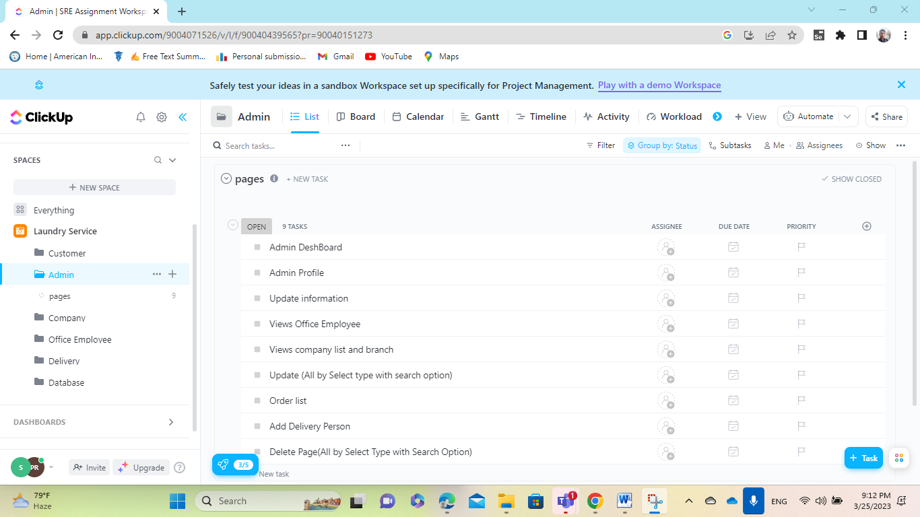

**Figure: Lists created for Admin.**

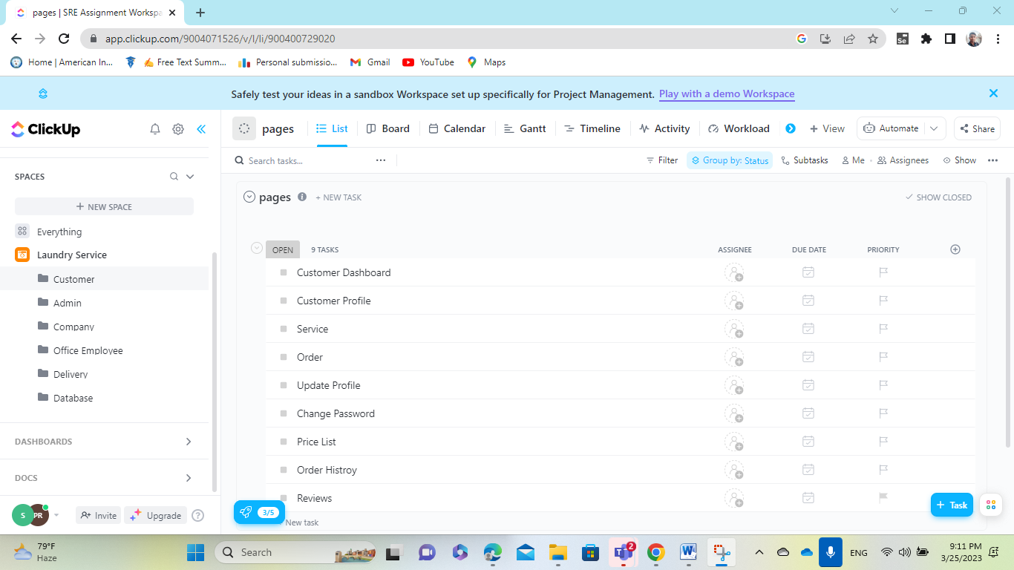

**Figure: Lists created for Customer.**

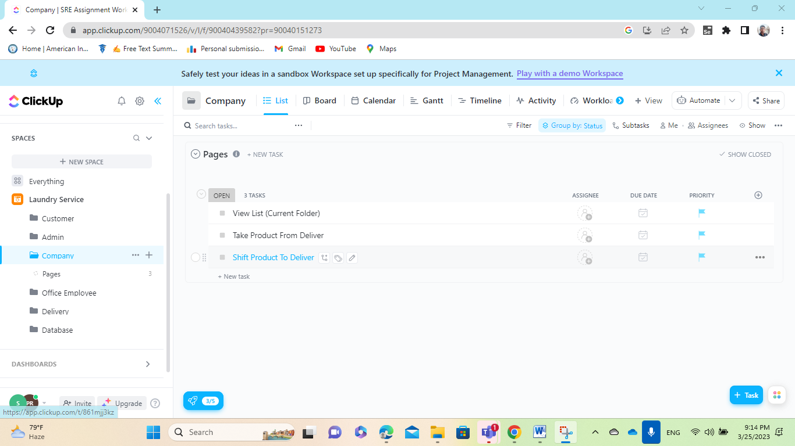

**Figure: Lists created for Company.**

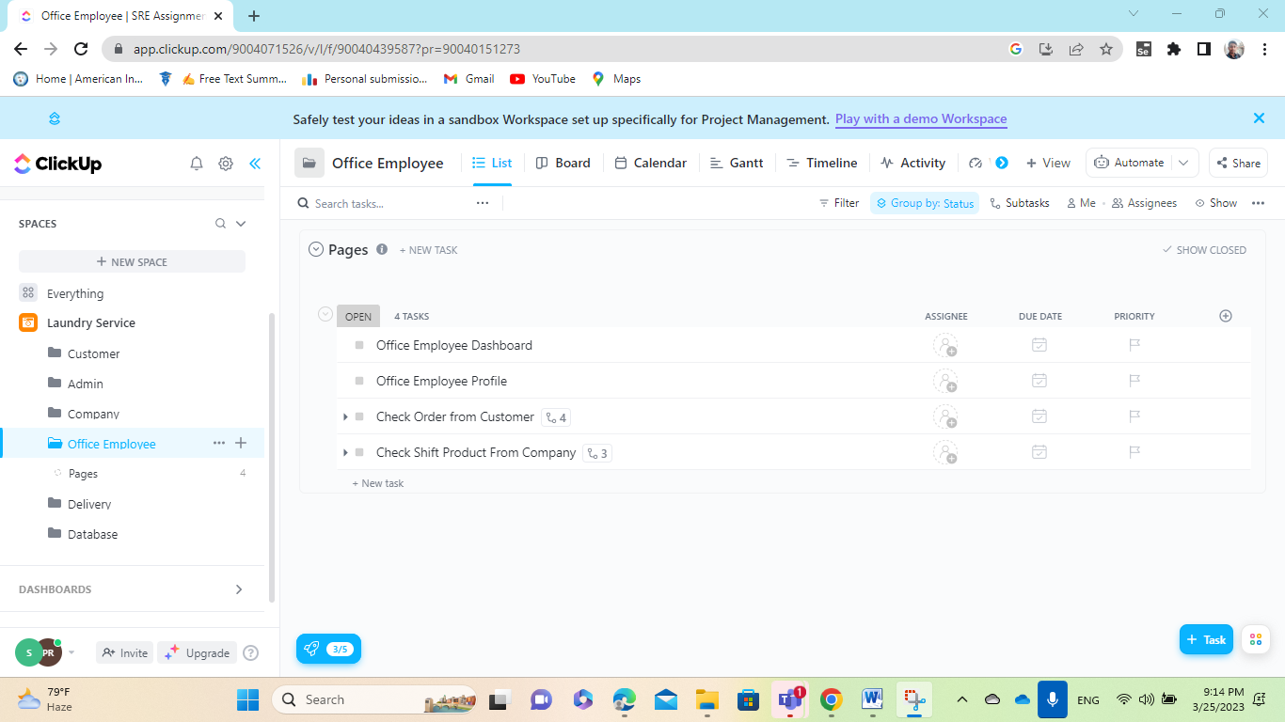

**Figure: Lists created for Office Employee.**

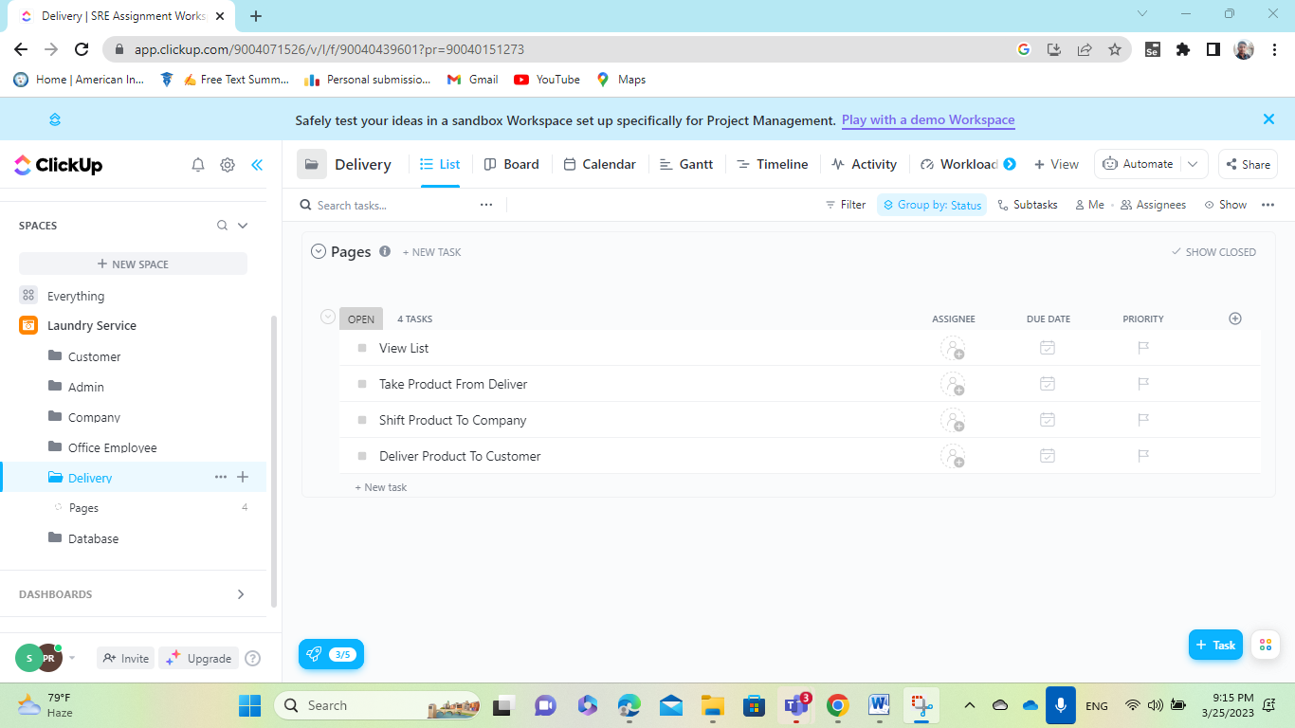

**Figure: Lists created for Delivery.**

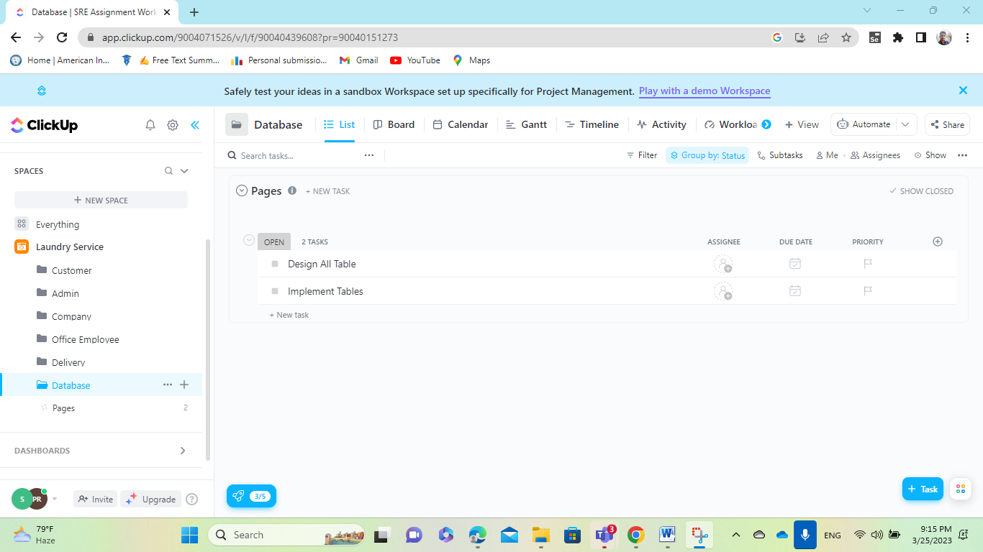

**Figure: Lists created for Database.**

**Assign Task:**

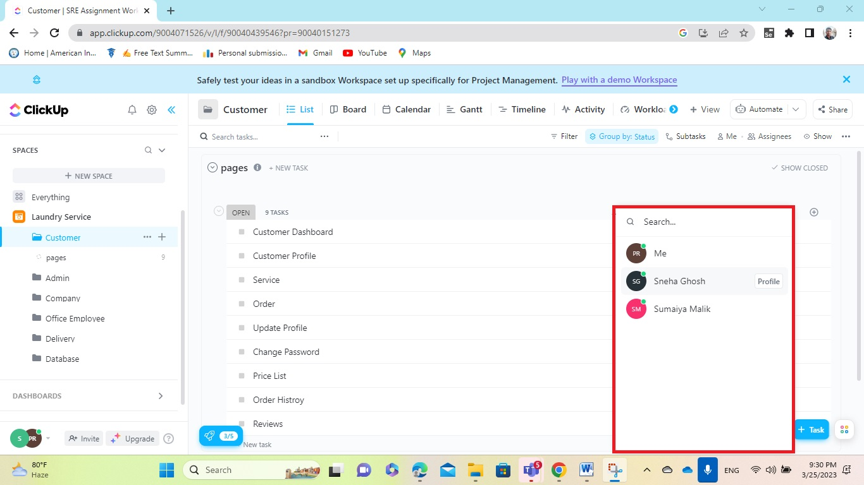

**Figure: Showing the way of assigning the tasks to group members.**

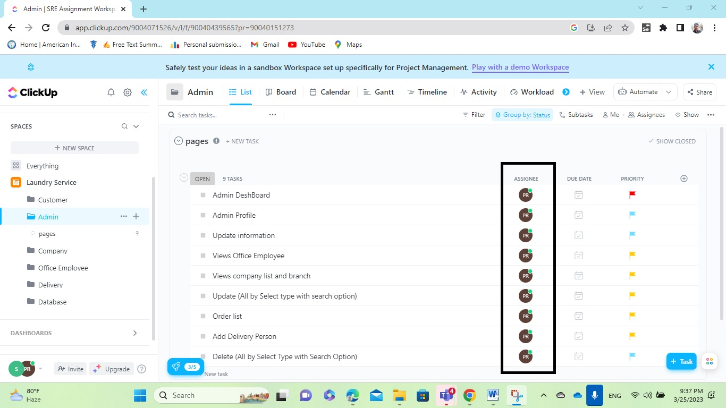

**Figure: Assigning the tasks for Admin to group members.**

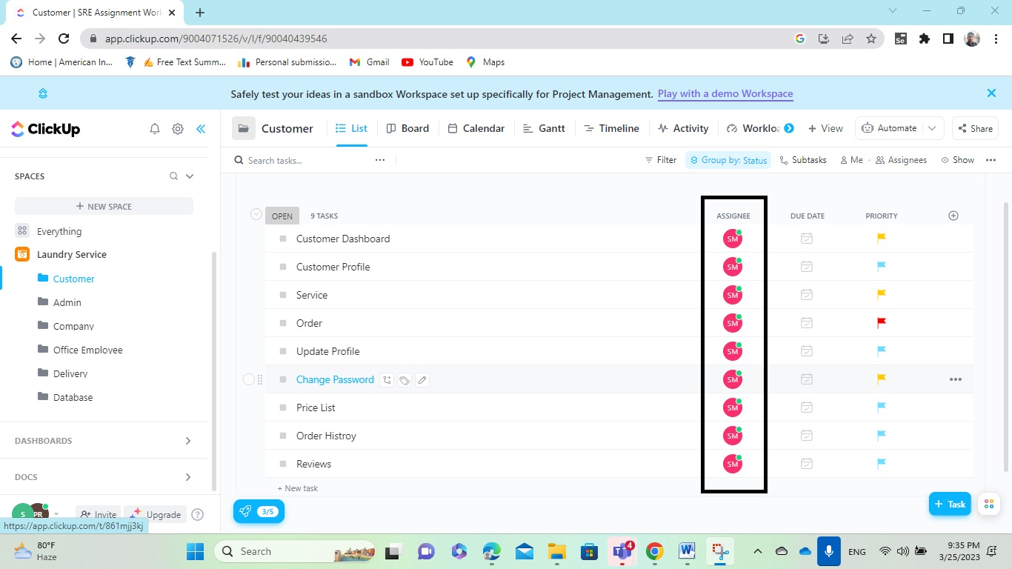

**Figure: Assigning the tasks for Customer to group members.**

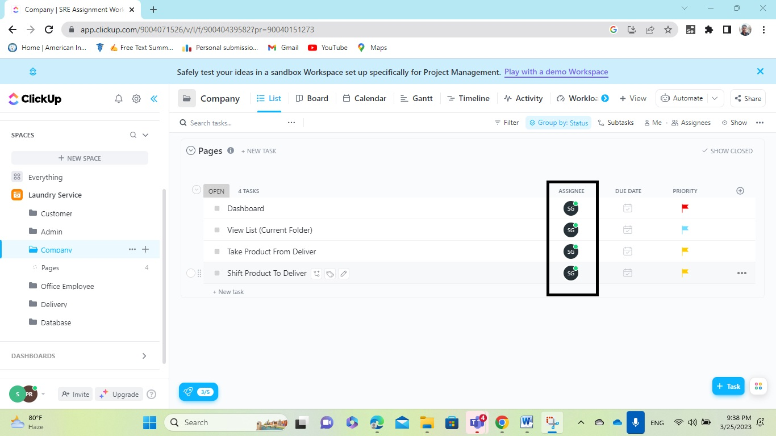

**Figure: Assigning the tasks for Company to group members.**

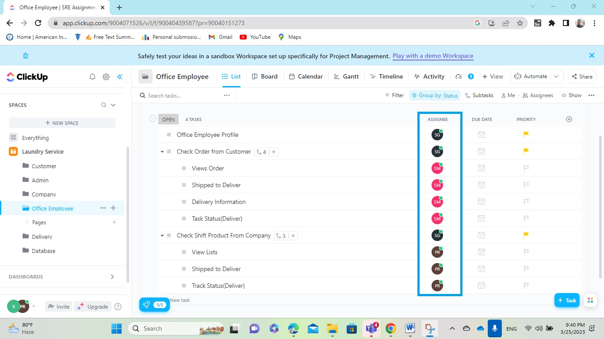

**Figure: Assigning the tasks for Office Employee to group members.**

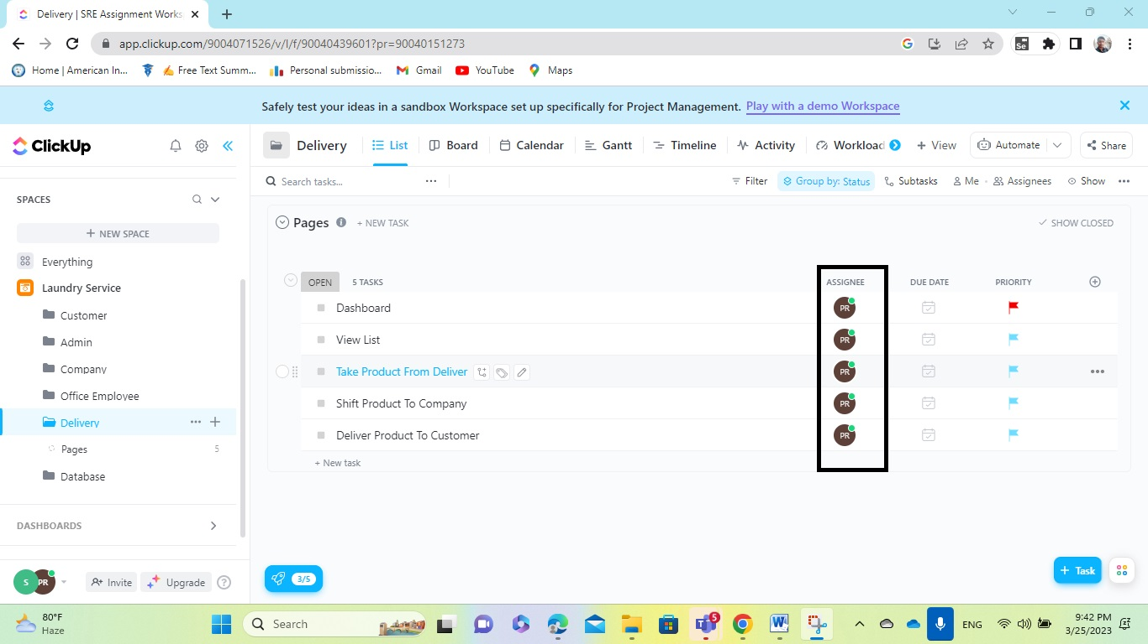

**Figure: Assigning the tasks for Delivery to group members.**

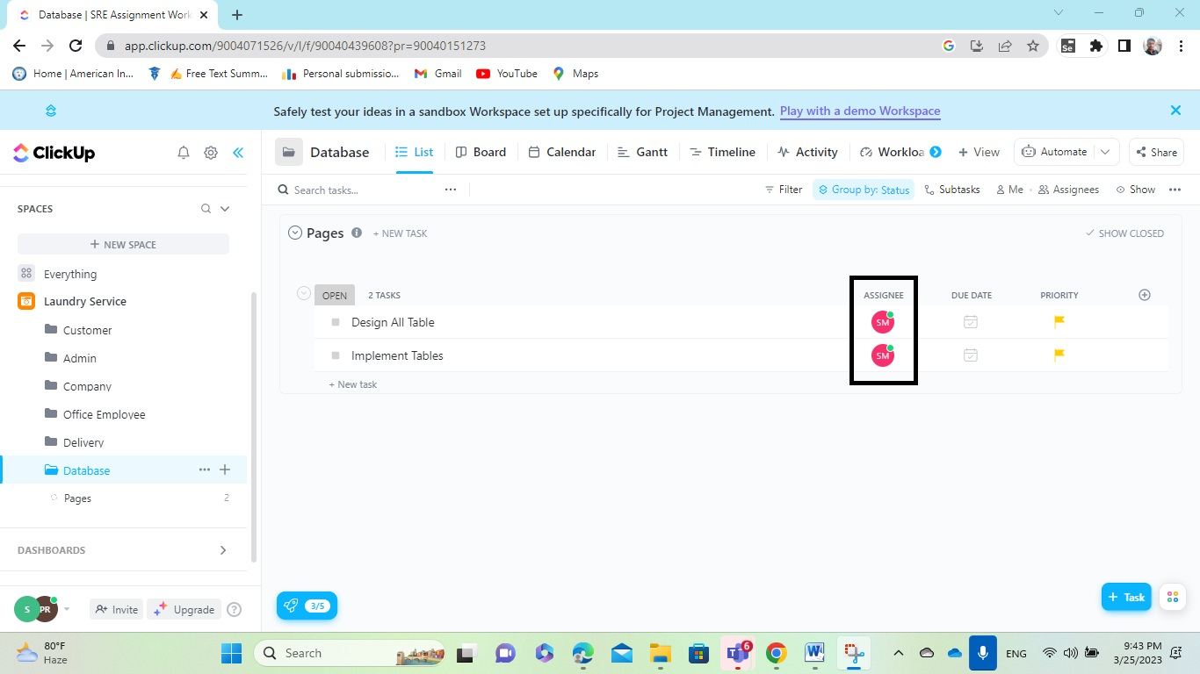

**Figure: Assigning the tasks for Database to group members.**

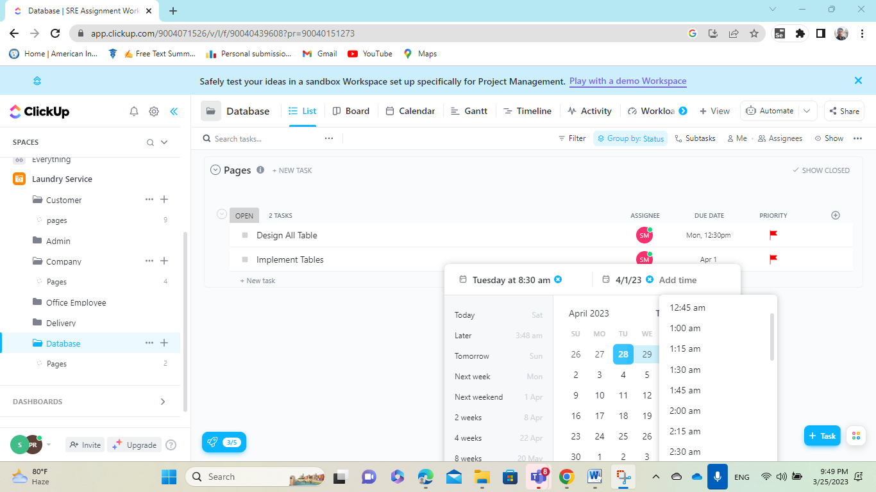

**Figure: Showing the way of allocating due date to group members.**

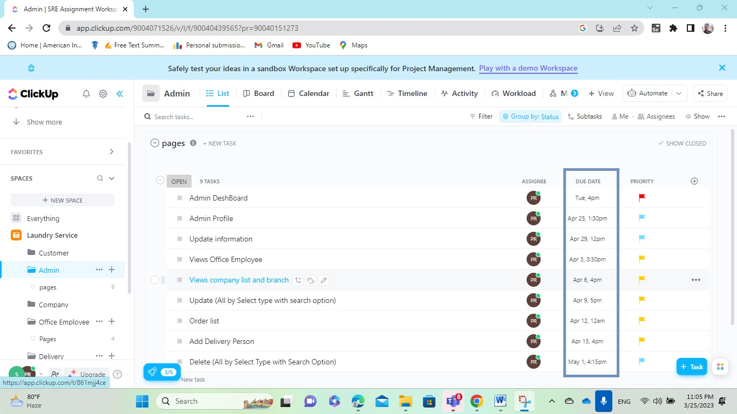

**Figure: Allocating the due date for Admin to group members.**

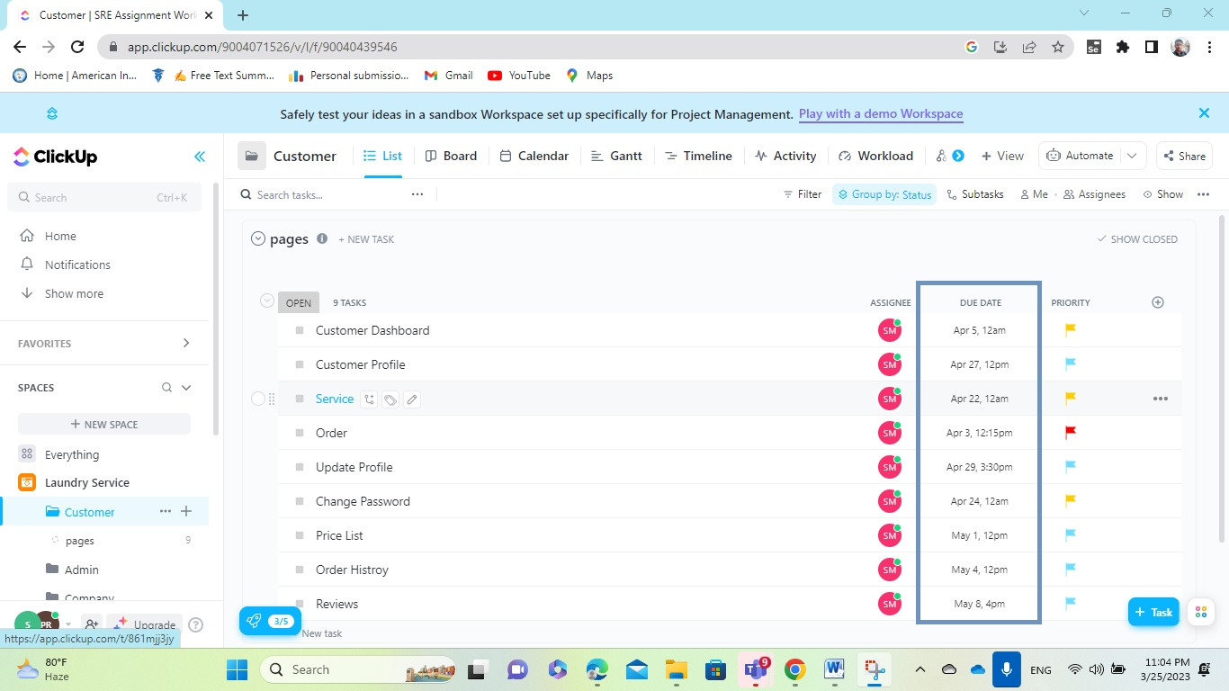

**Figure: Allocating the due date for Customer to group members.**

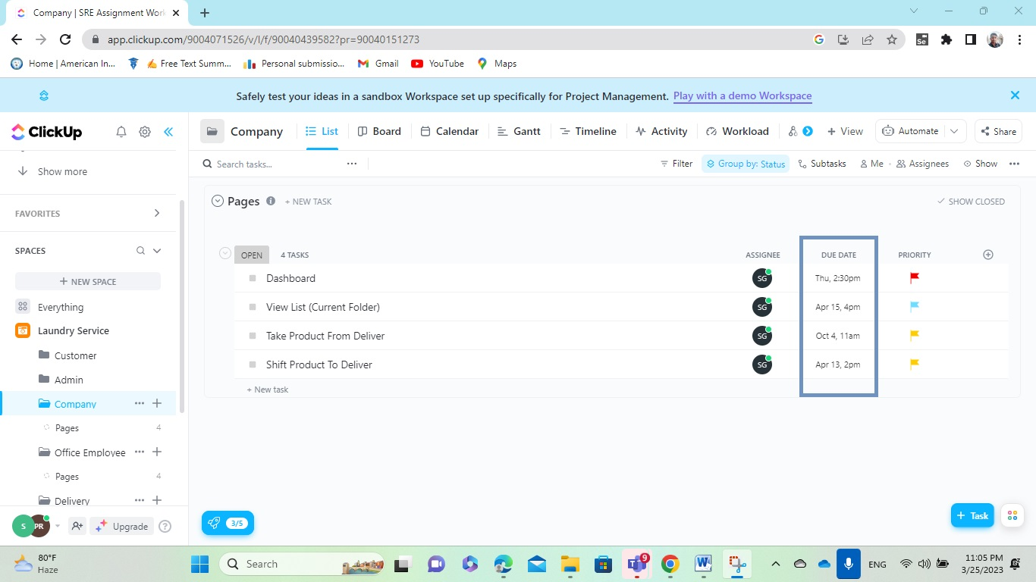

**Figure: Allocating the due date for Company to group members.**

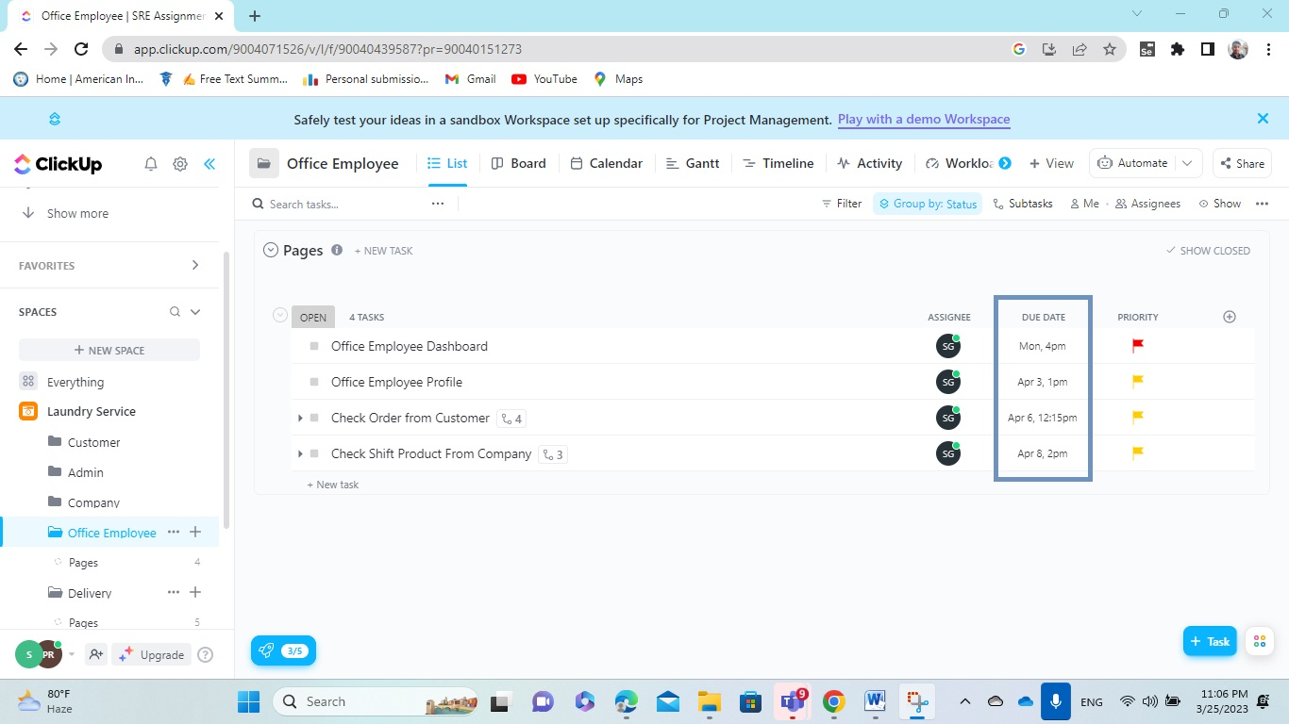

**Figure: Allocating the due date for Office Employee to group members.**

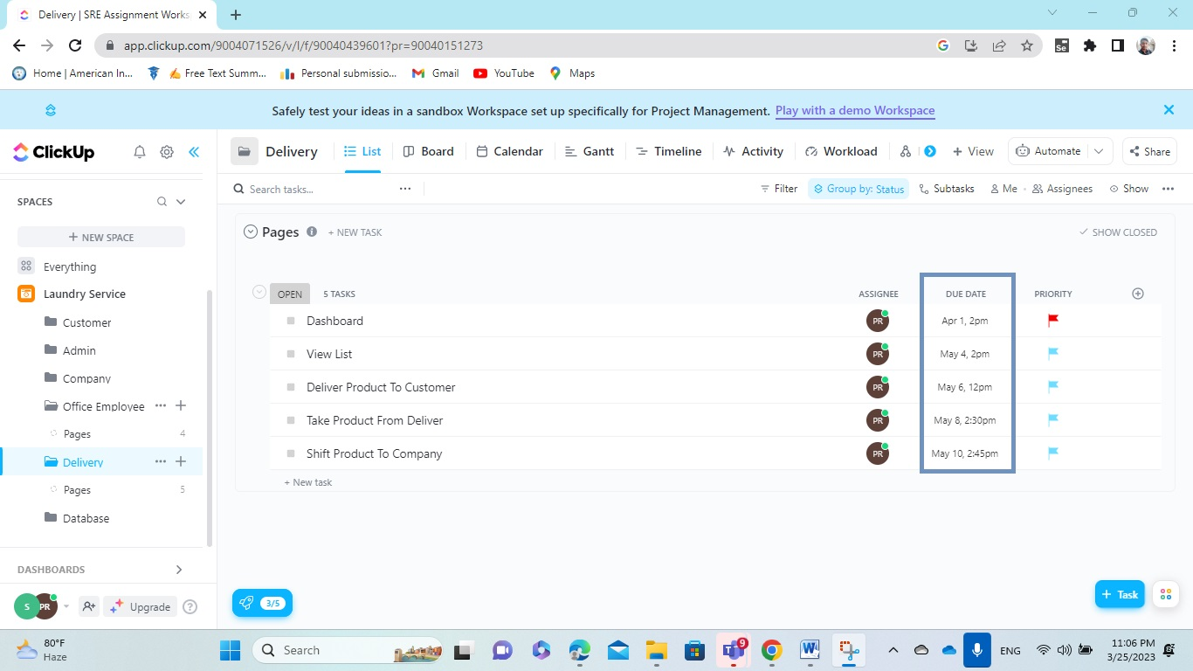

**Figure: Allocating the due date for Delivery to group members.**

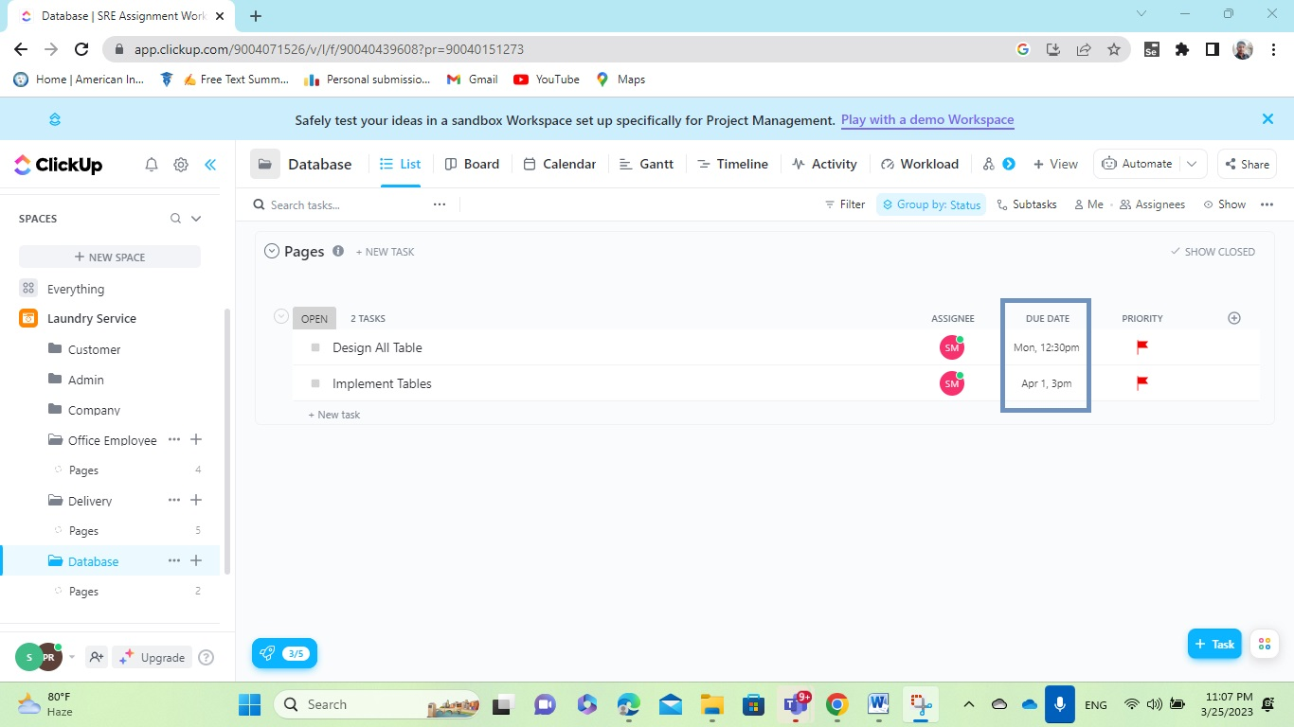

**Figure: Allocating the due date for Database to group members.**

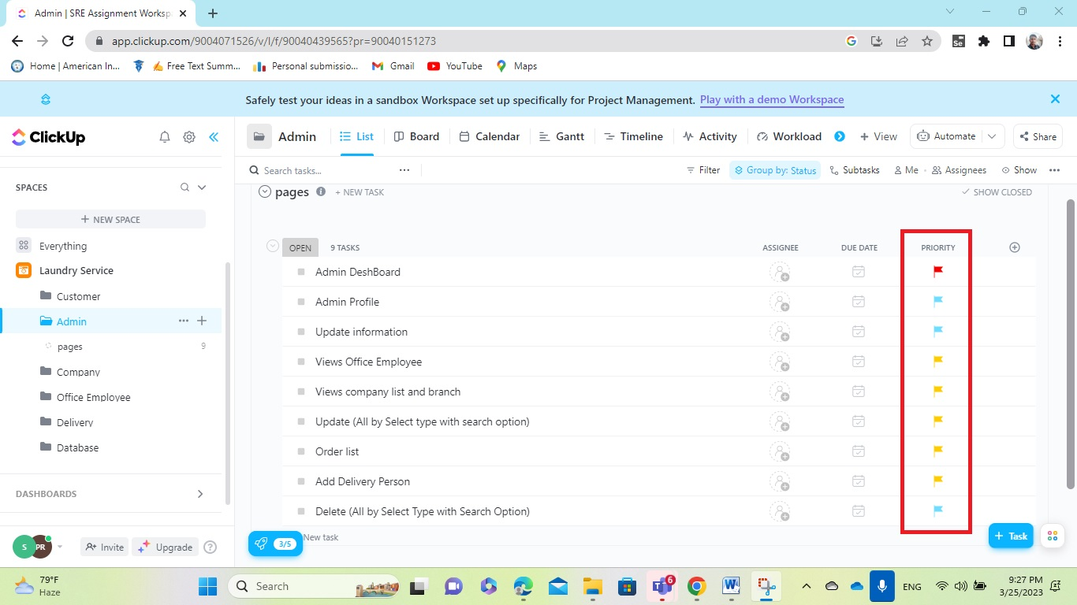

**Figure: Allocating the Priority for the task of Admin.**

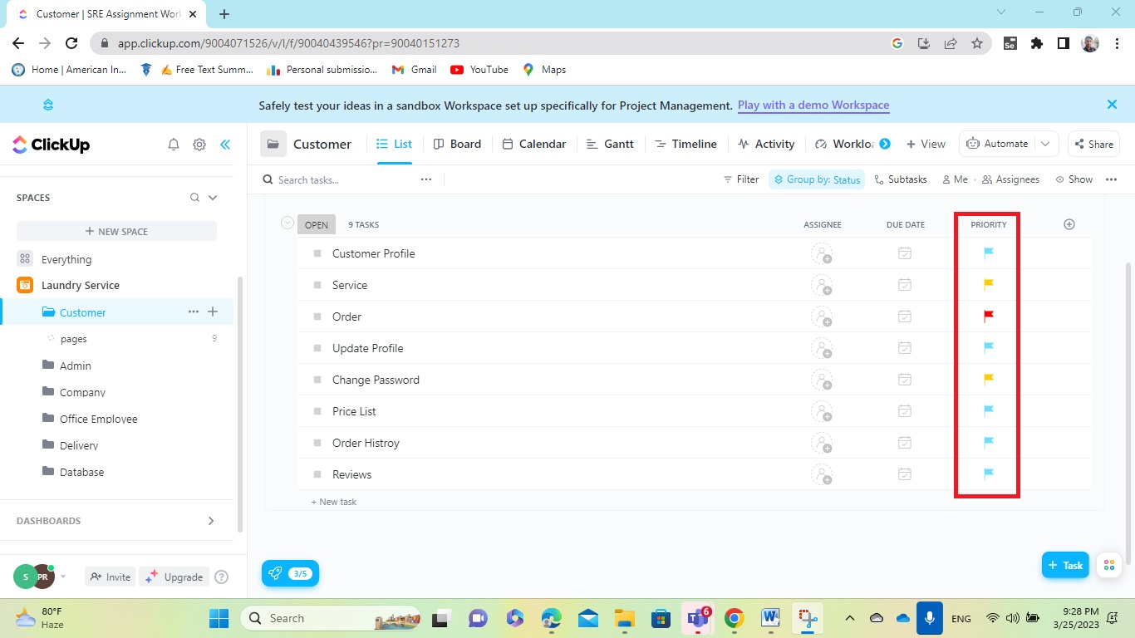

**Figure: Allocating the Priority for the task of Customer.**

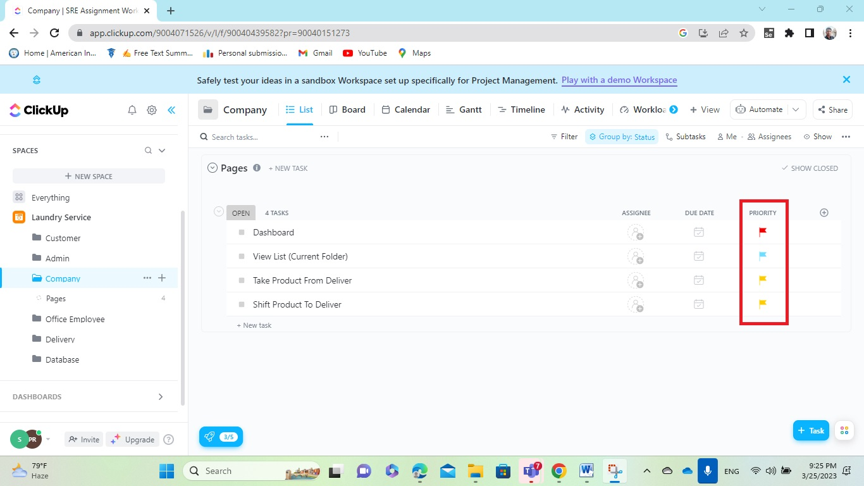

**Figure: Allocating the Priority for the task of Company.**

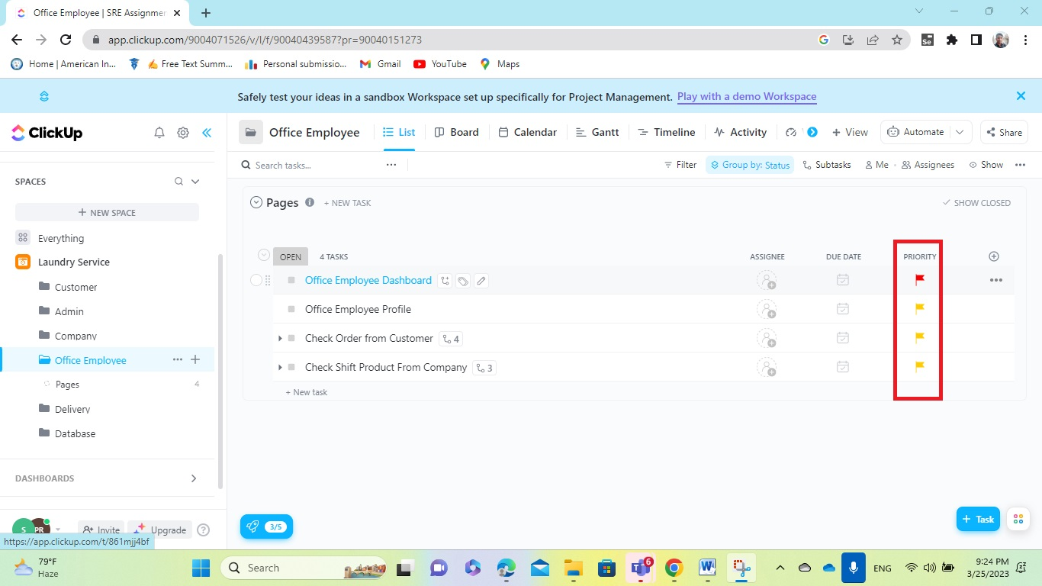

**Figure: Allocating the Priority for the task of Office Employee.**

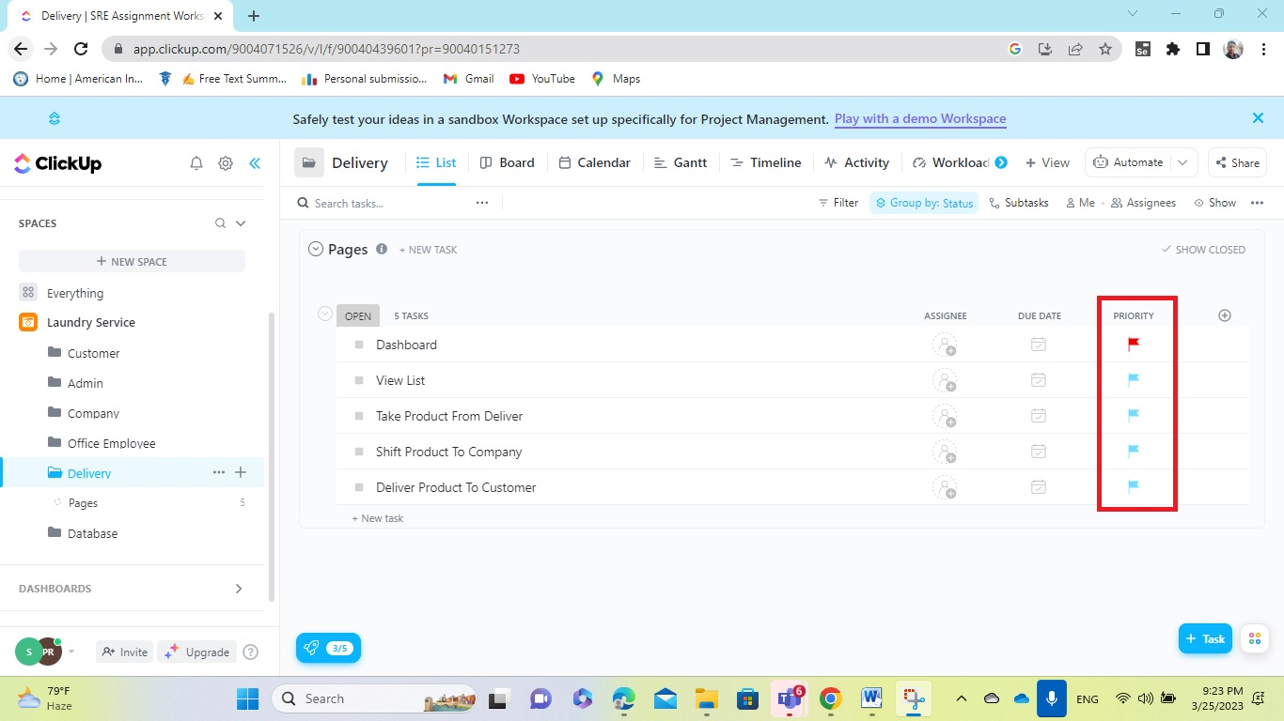

**Figure: Allocating the Priority for the task of Delivery.**

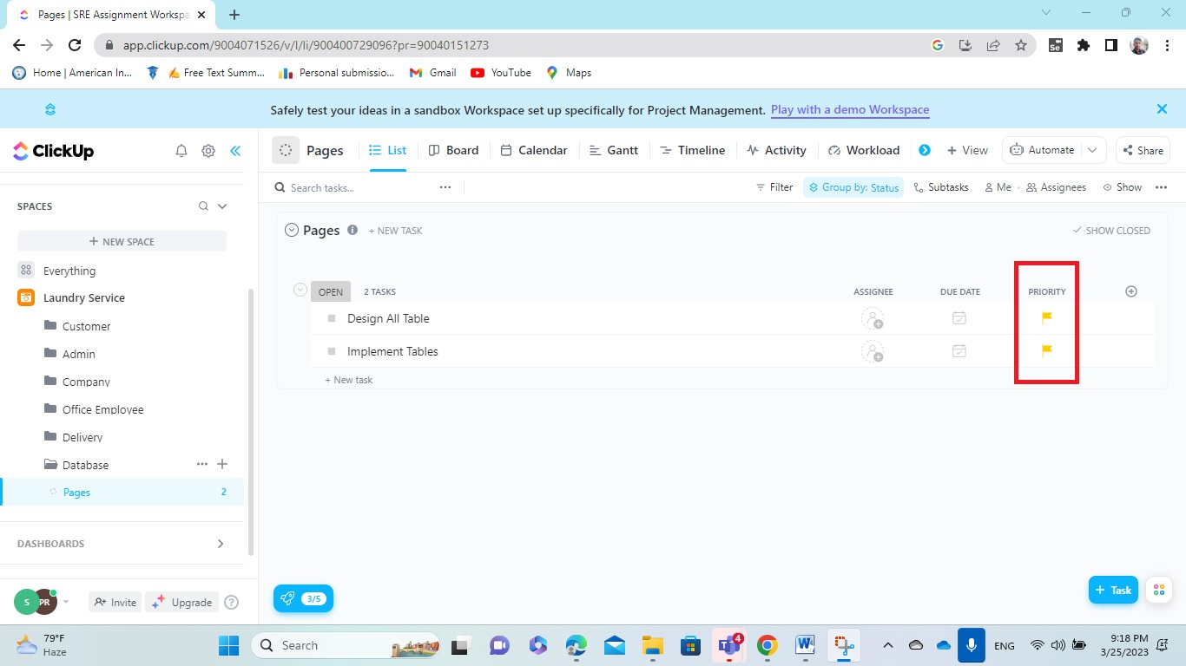

**Figure: Allocating the Priority for the task of Database.**

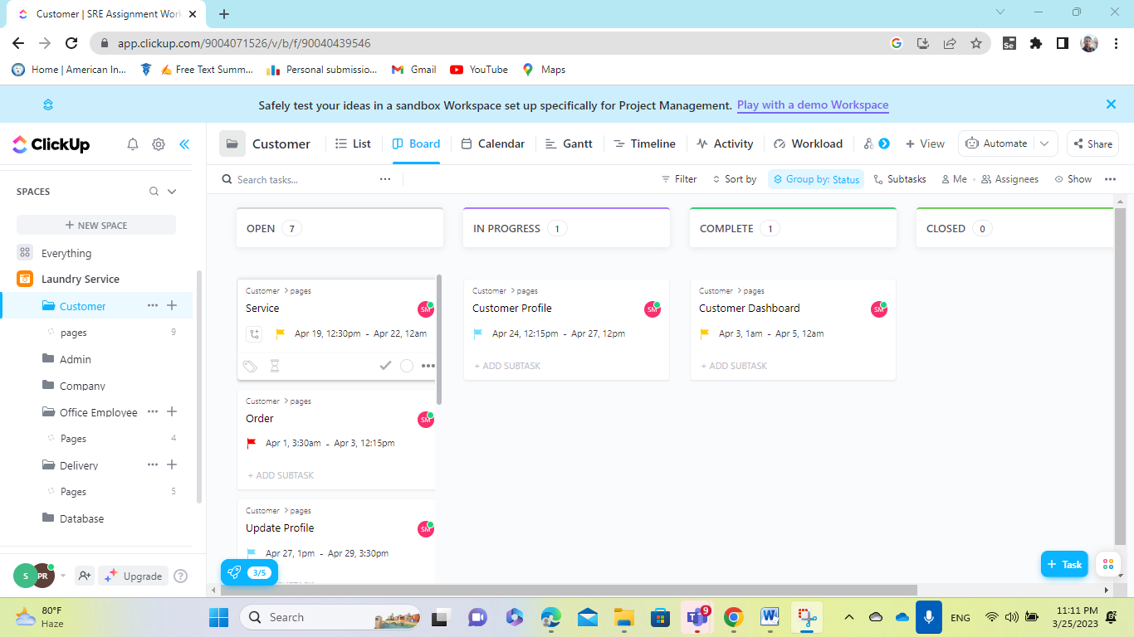

**Figure Showing Board task view for Customer.**

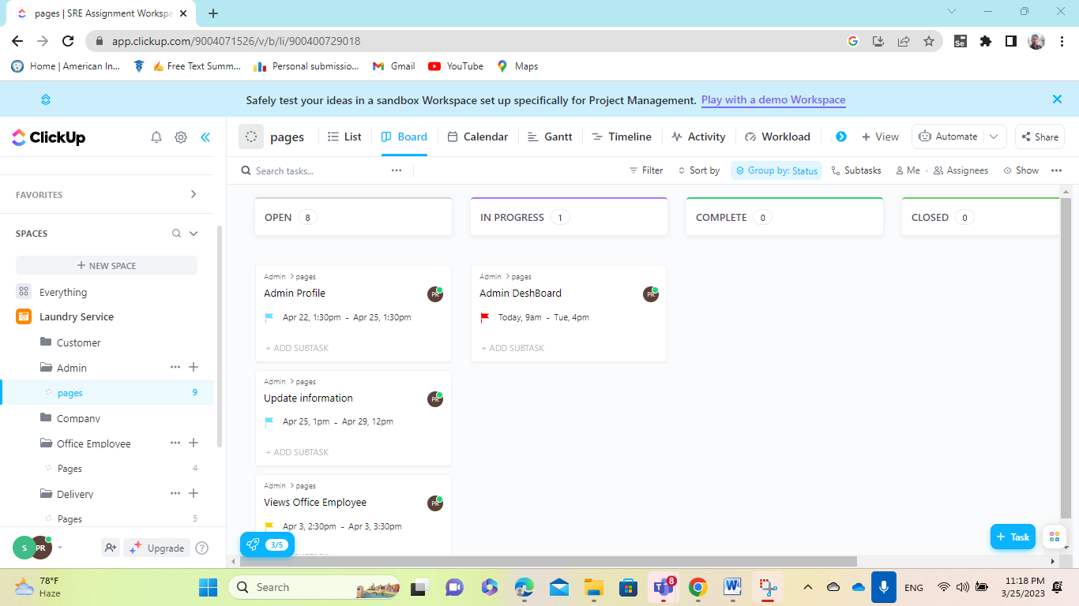

**Figure: Showing Board task view for Admin.**

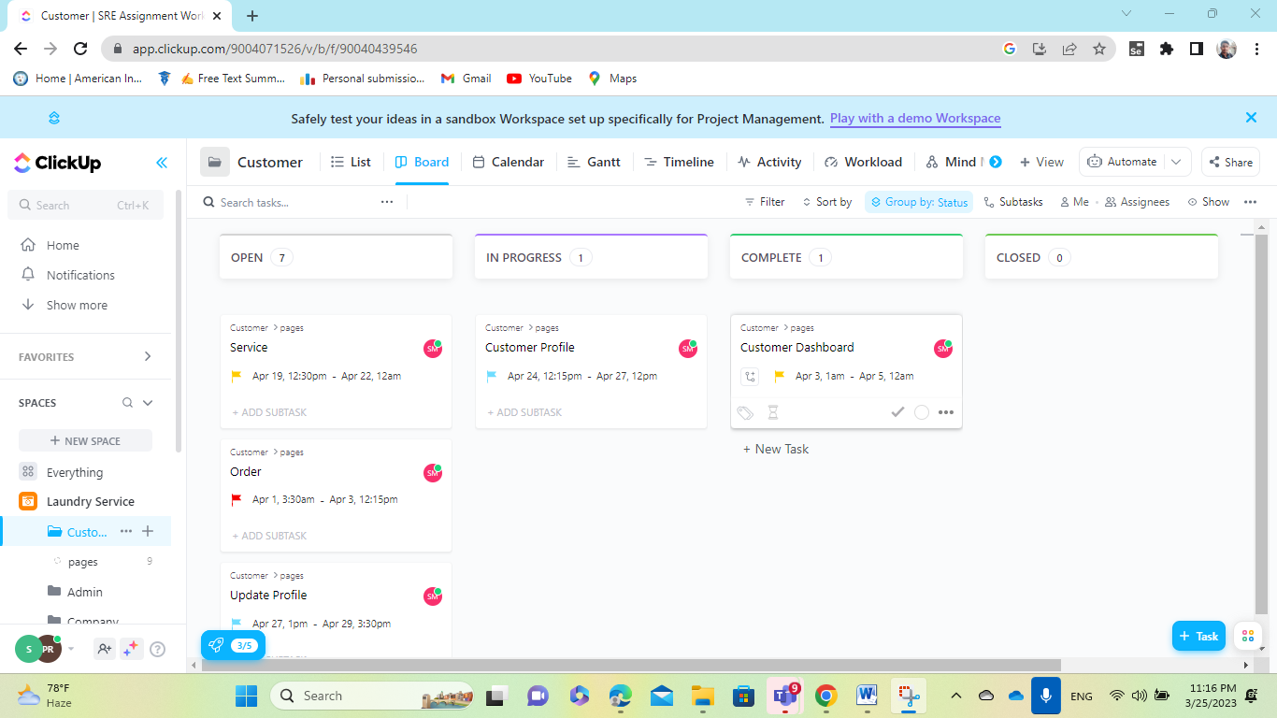

**Figure: Showing Board task view for Customer.**

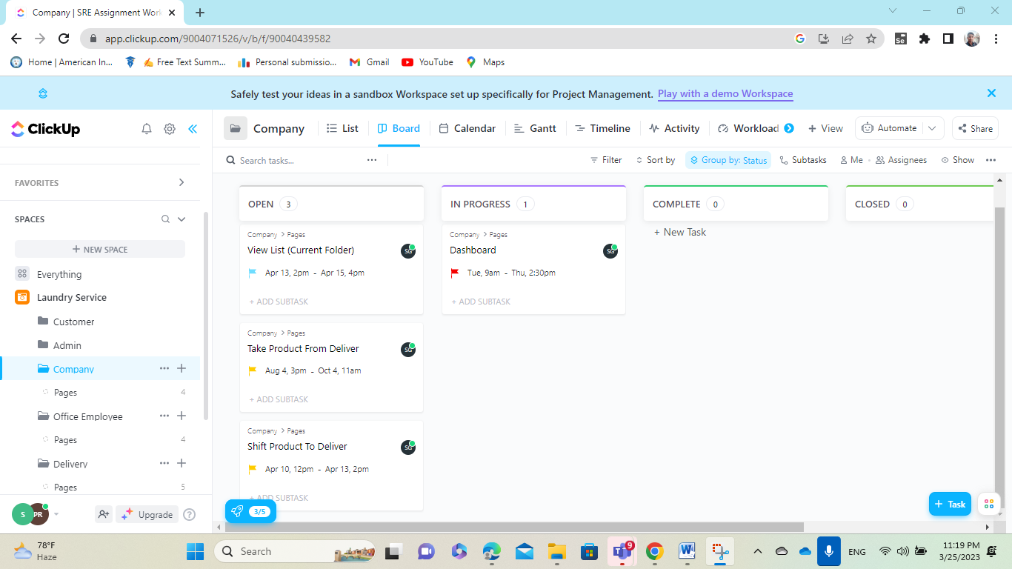

**Figure: Showing Board task view for Company.**

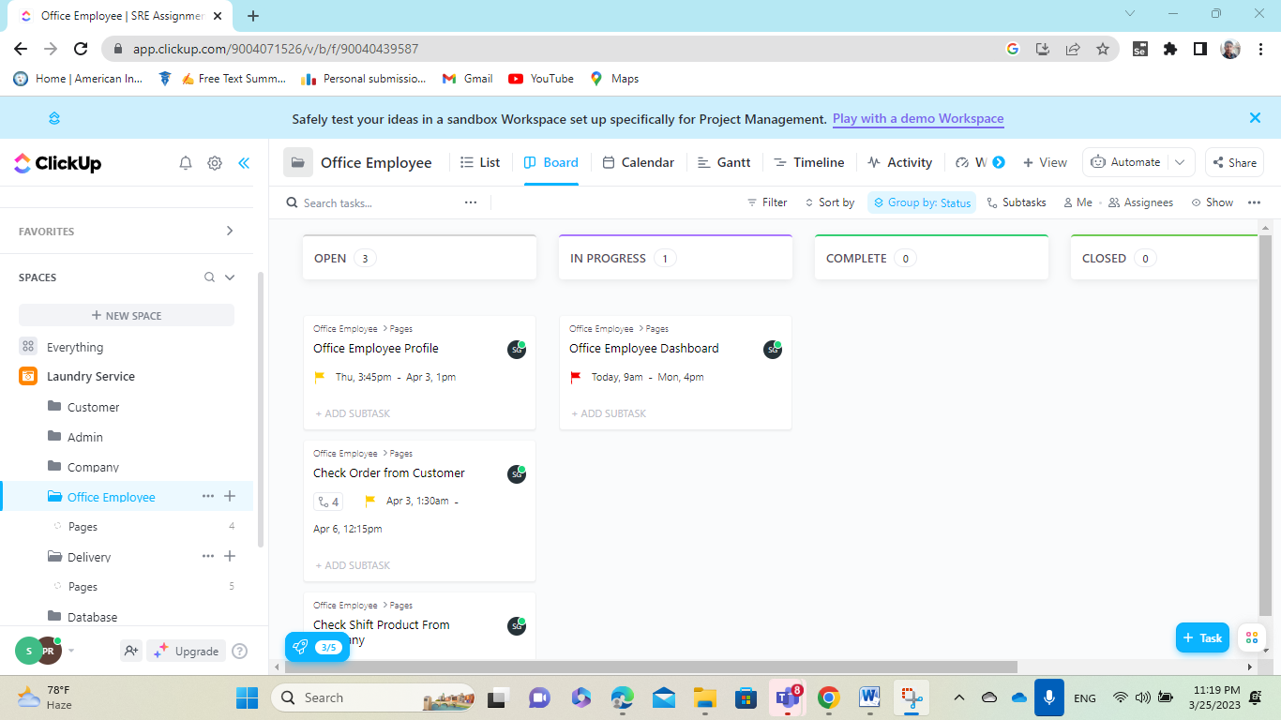

**Figure: Showing Board task view for Office Employee.**

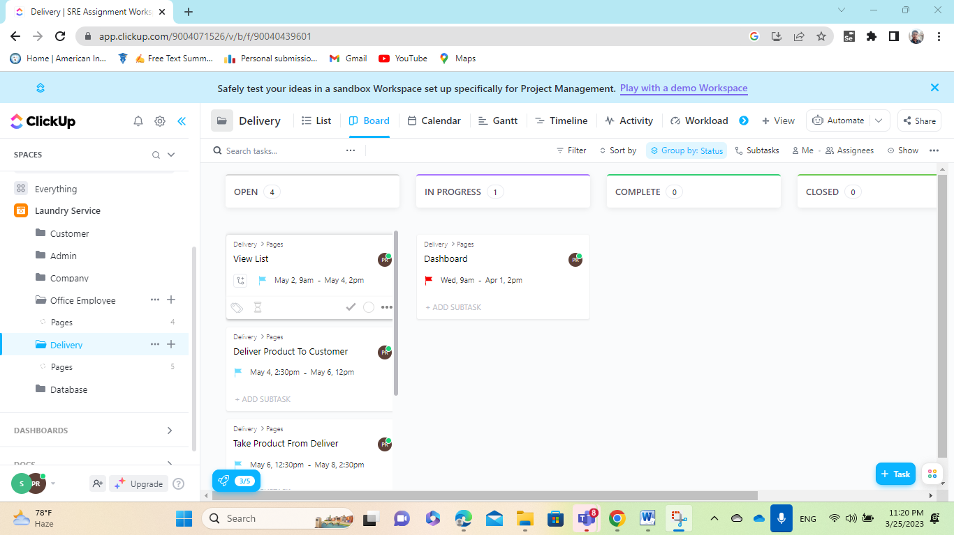

**Figure: Showing Board task view for Delivery.**

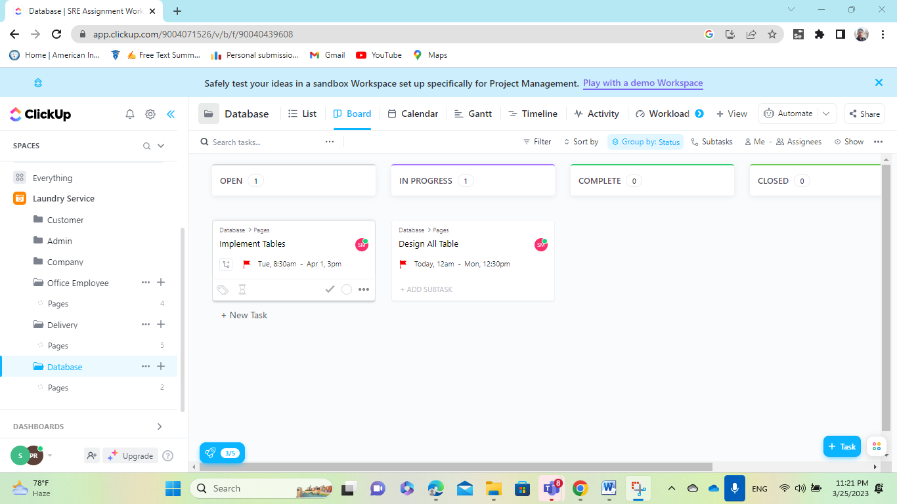

**Figure: Showing Board task view for Database.**

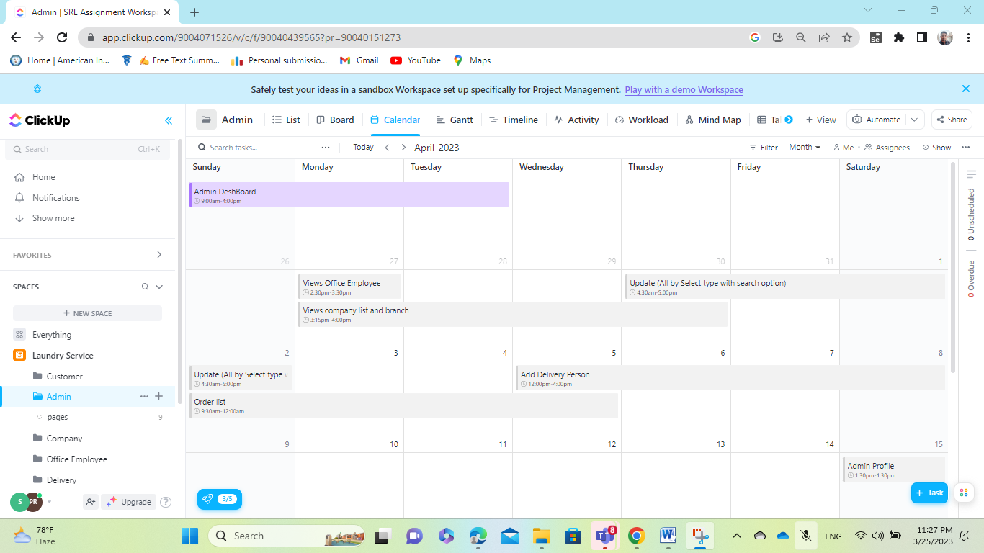

**Figure: Showing Calander view for Admin.**

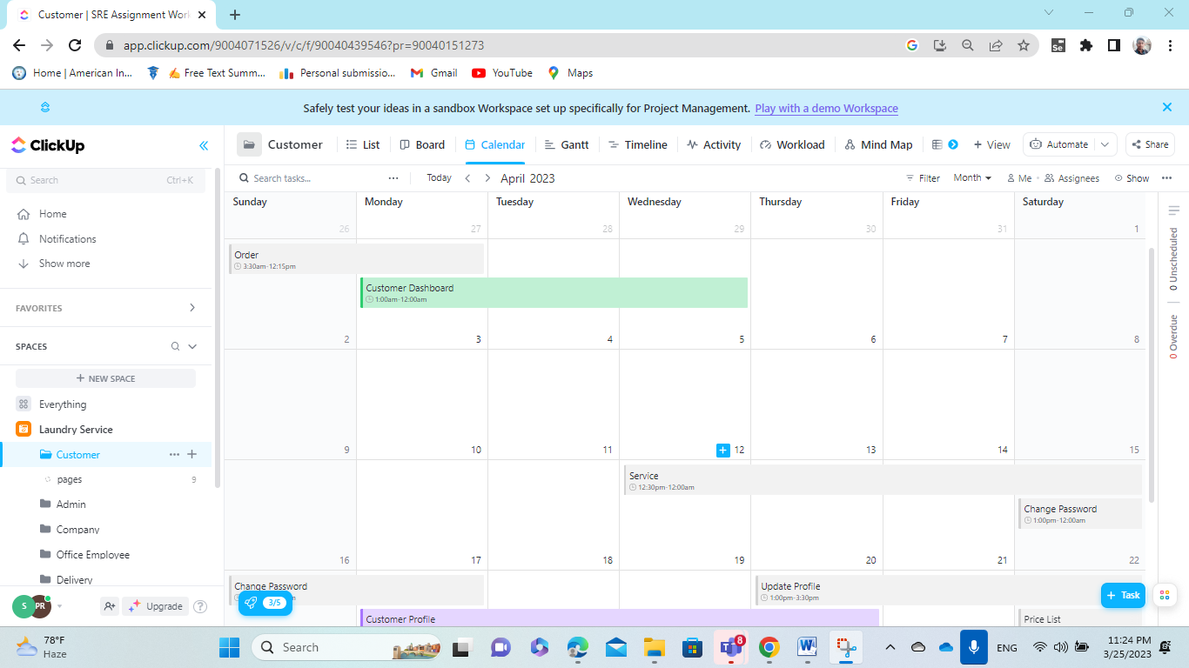

**Figure: Showing Calendar view for Customer.**

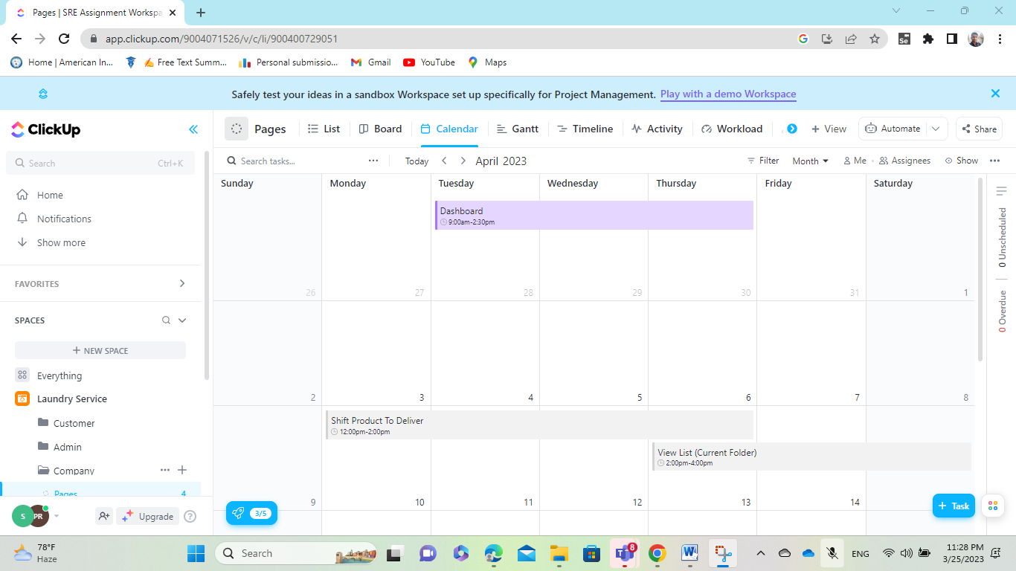

**Figure: Showing Calendar view for Company.**

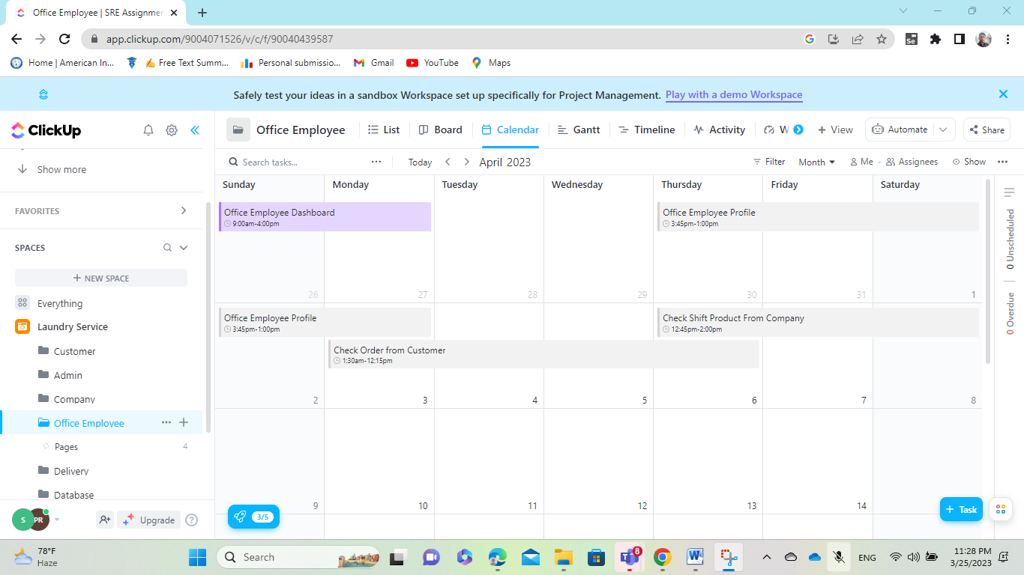

**Figure: Showing Calendar view for Office Employee.**

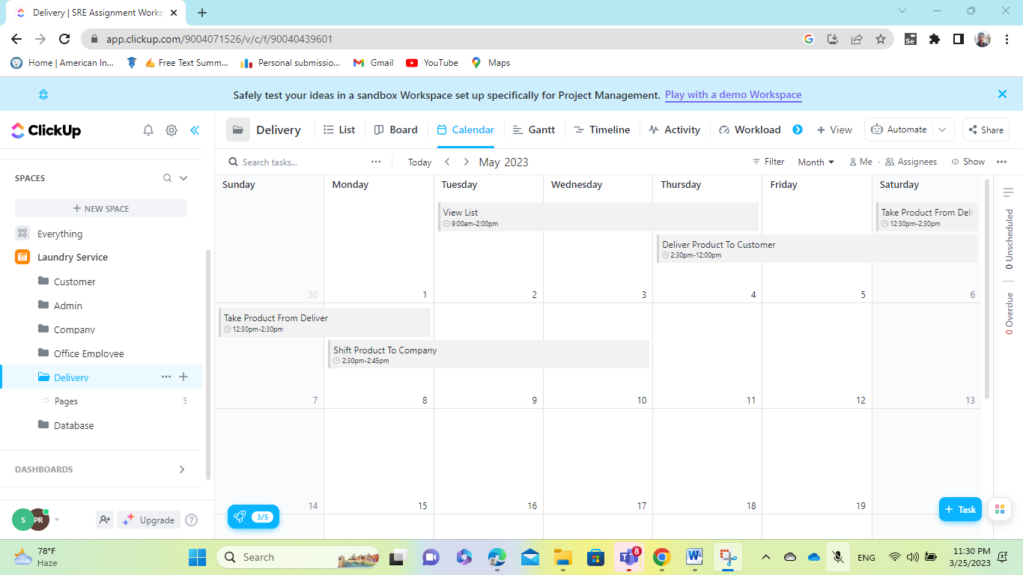

**Figure: Showing Calendar view for Delivery.**

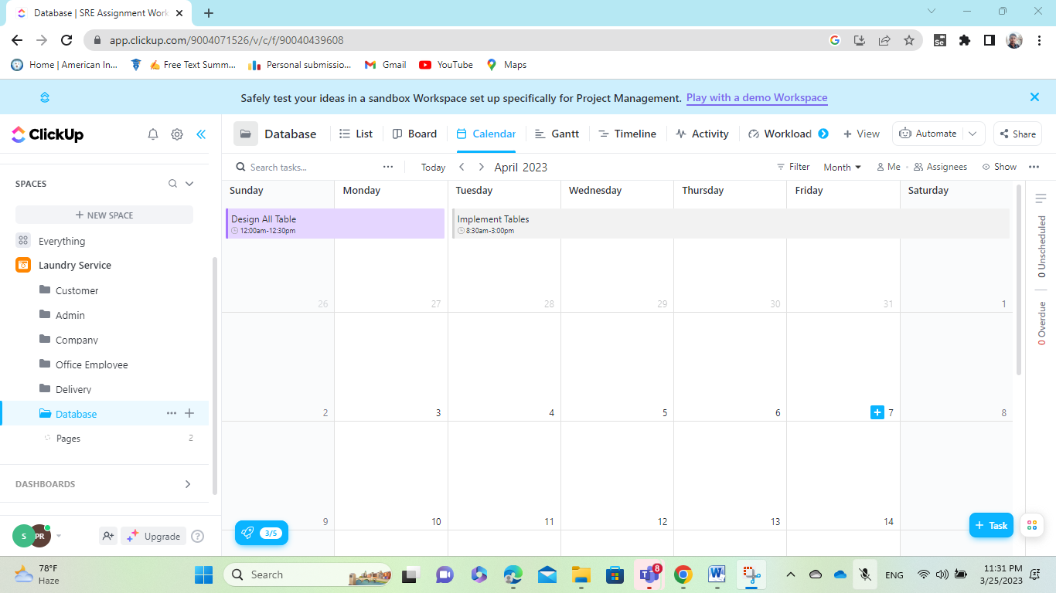

**Figure: Showing Calendar view for Database.**

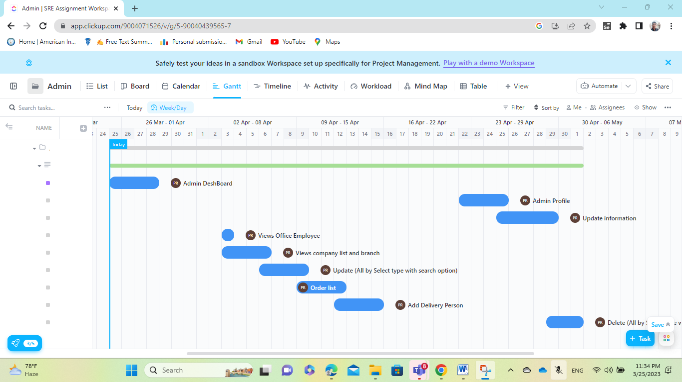

**Figure: Showing Gantt view for Admin.**

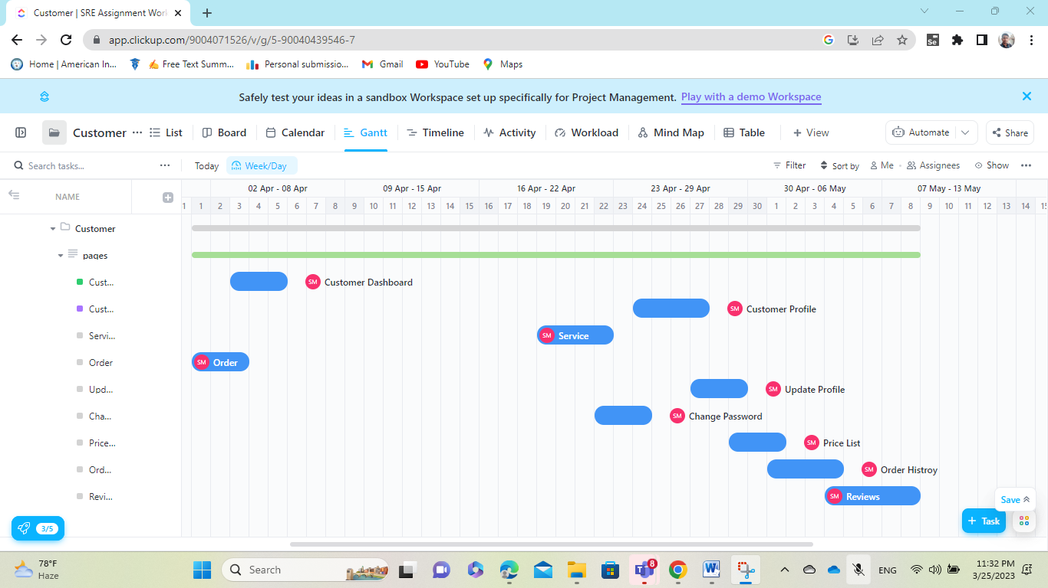

**Figure: Showing Gantt view for Customer.**



**Figure: Showing Gantt view for Company.**

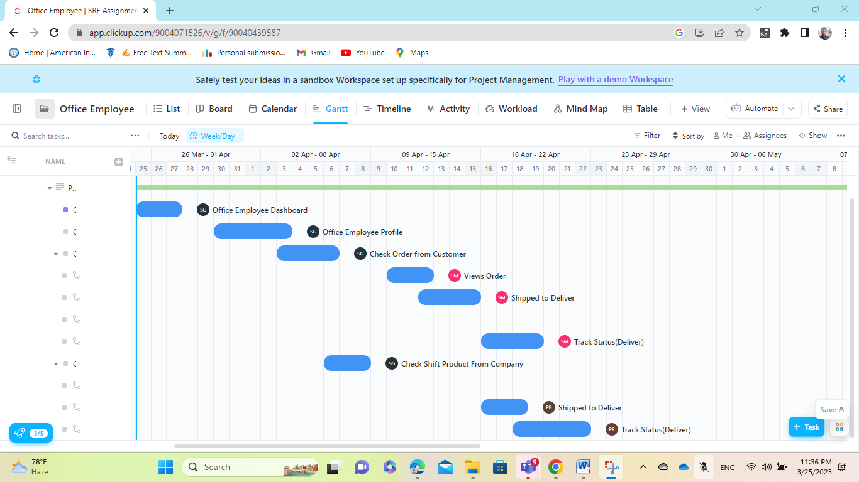

**Figure: Showing Gantt view for Office Employee.**

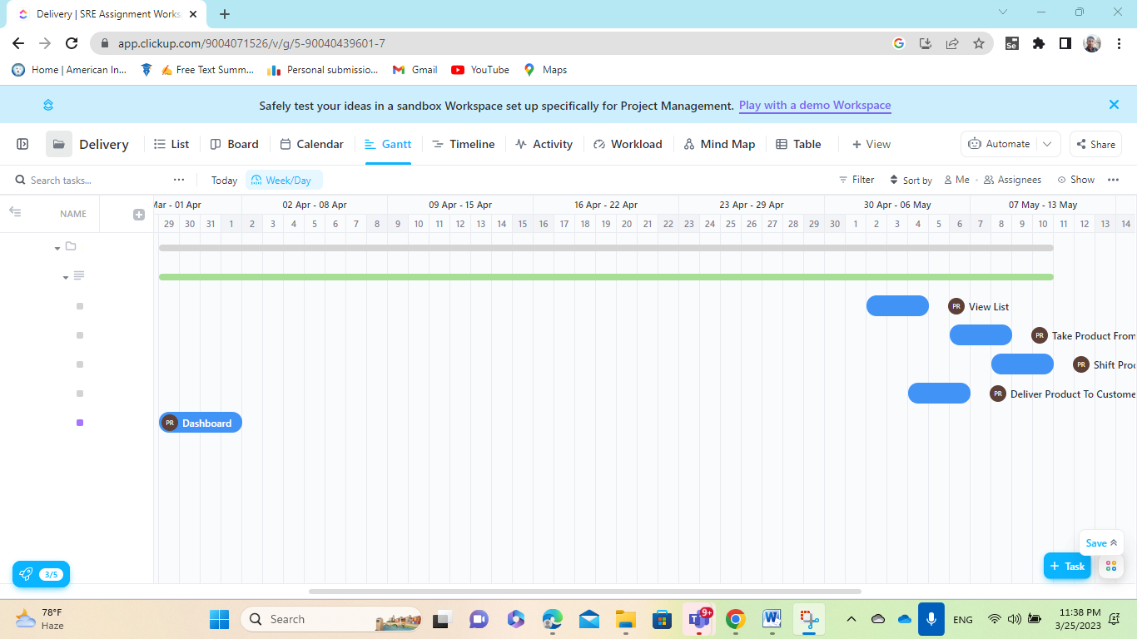

**Figure: Showing Gantt view for Delivery.**

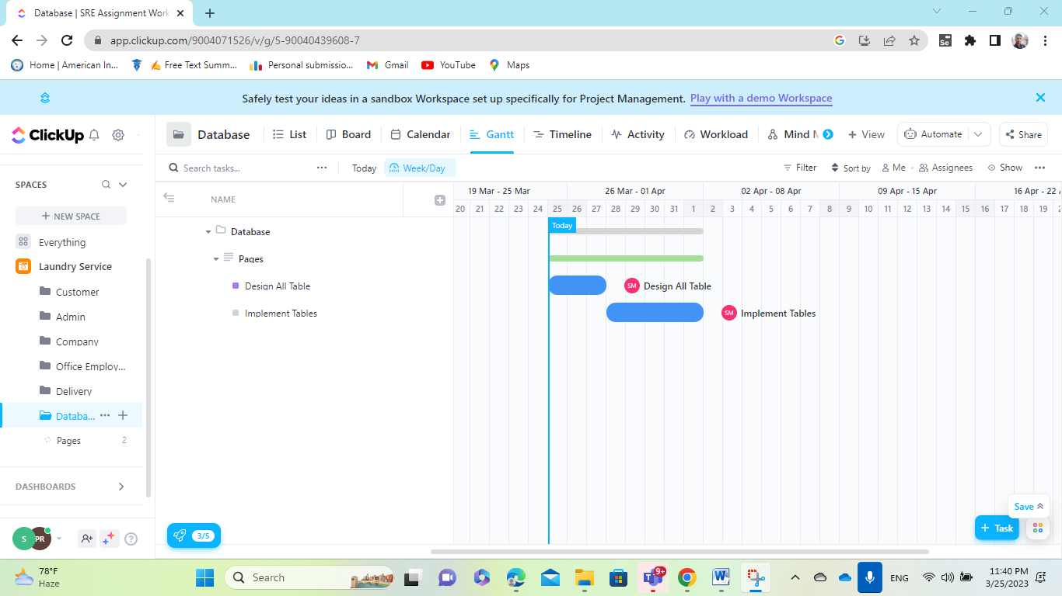

**Figure: Showing Gantt view for Database.**

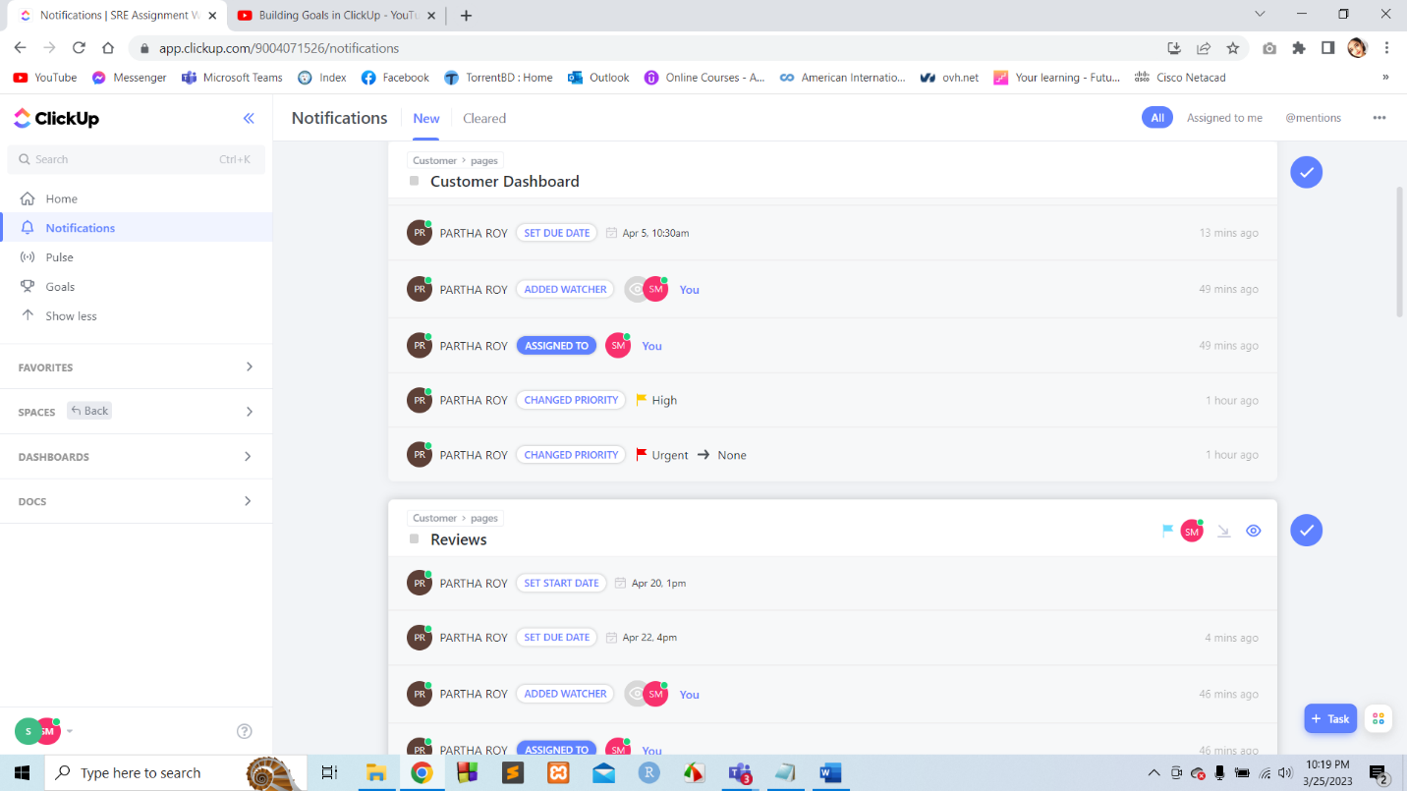

**Figure: Notifications received by Group members due to assigning tasks, allocating due dates and setting priorities.**

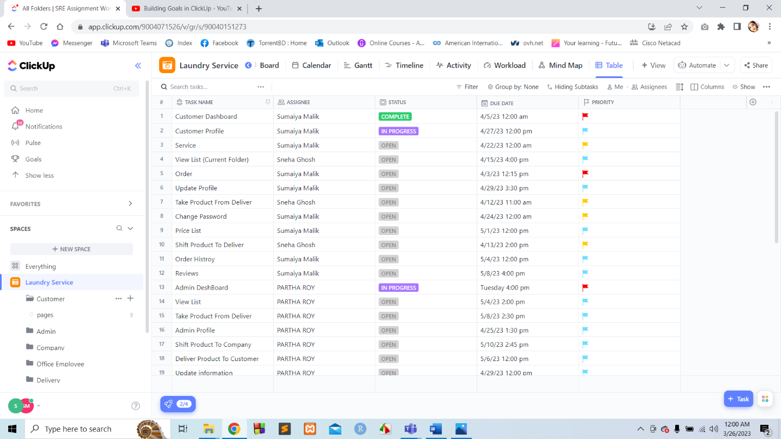

**Figure: The overall total list for the Space (Laundry Service).**

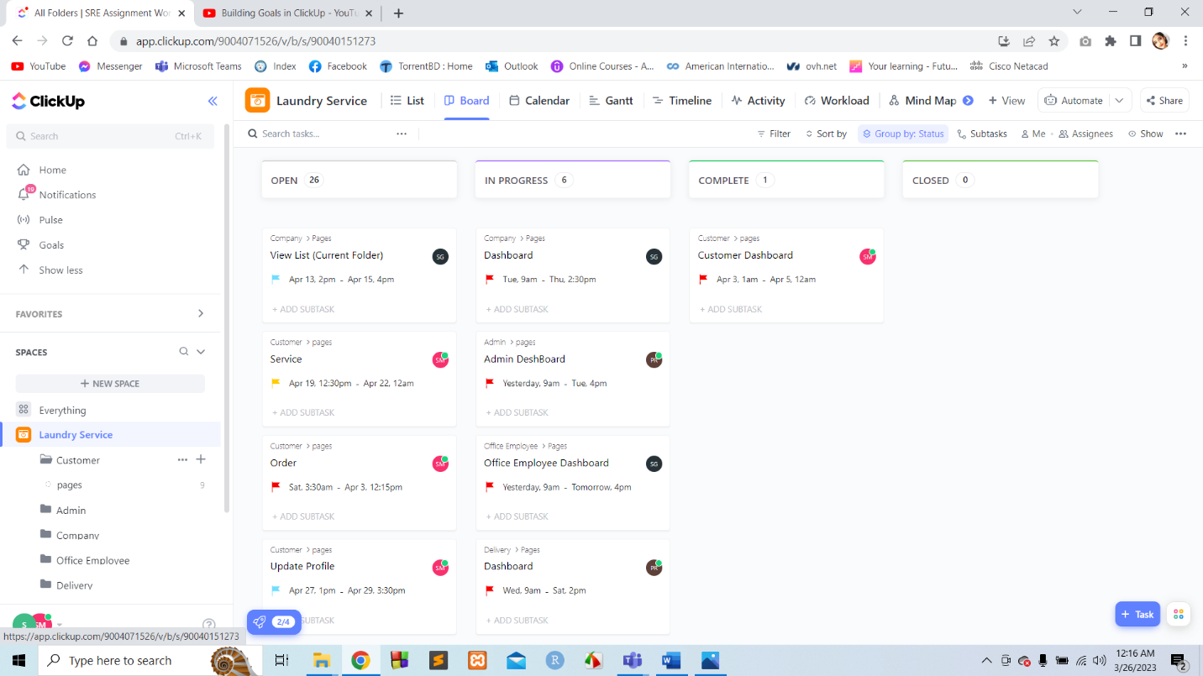

**Figure: The overall total Board for the Space (Laundry Service).**

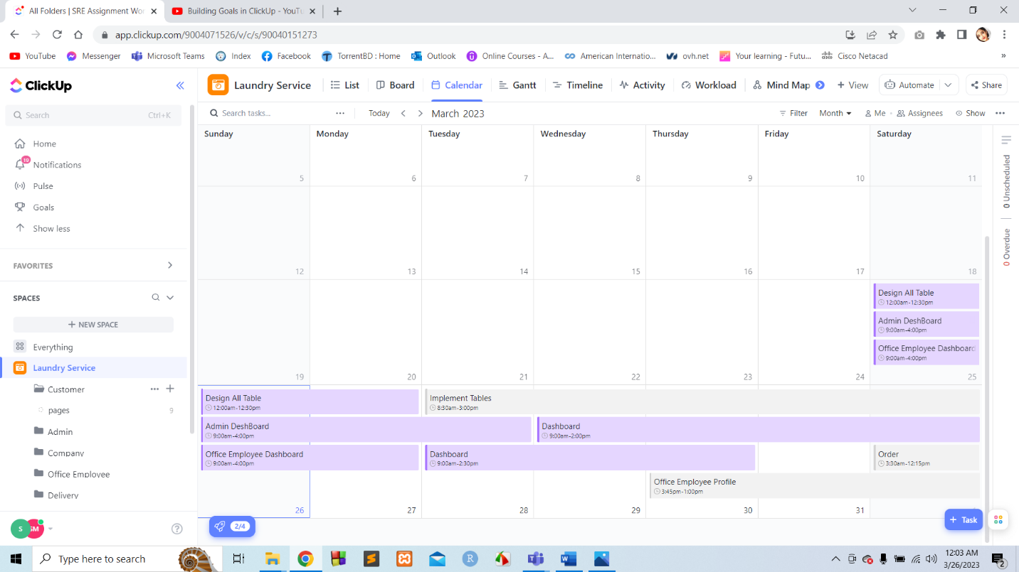

**Figure: The overall total Calander for the Space (Laundry Service).**

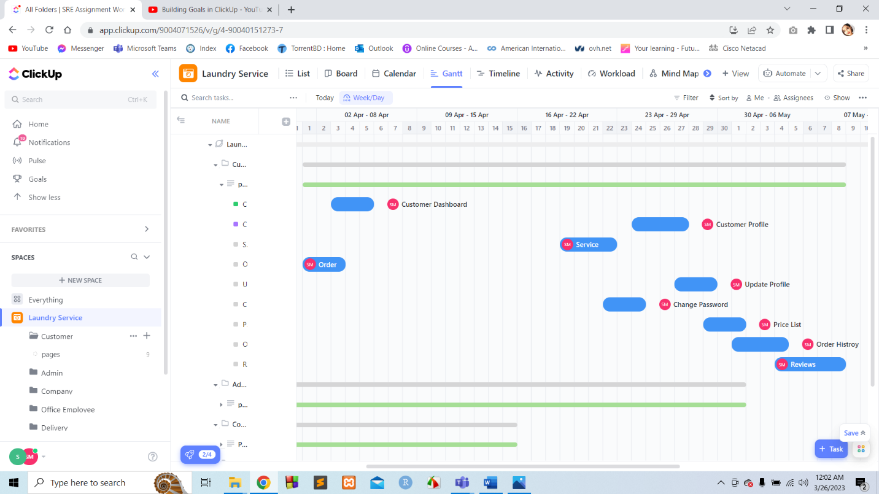

**Figure: The overall total Gantt for the Space (Laundry Service).**

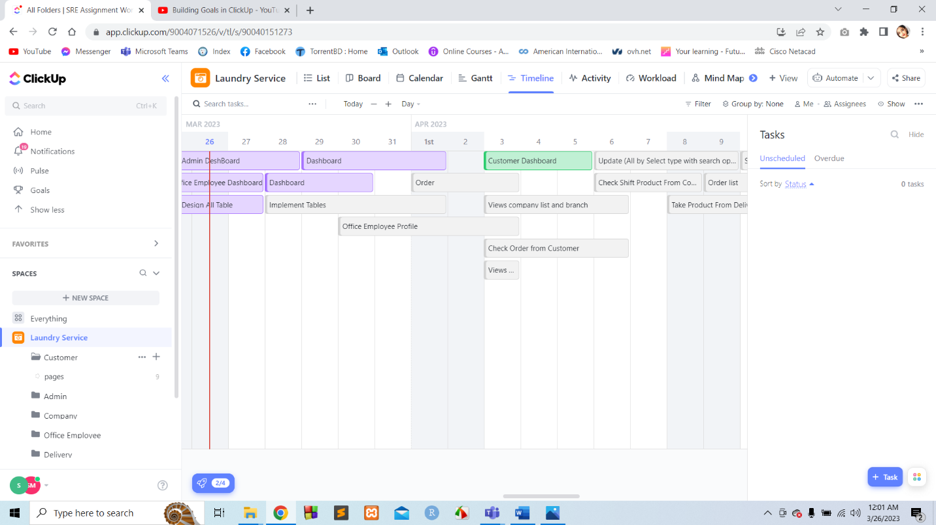

**Figure: The overall total Timeline for the Space (Laundry Service).**

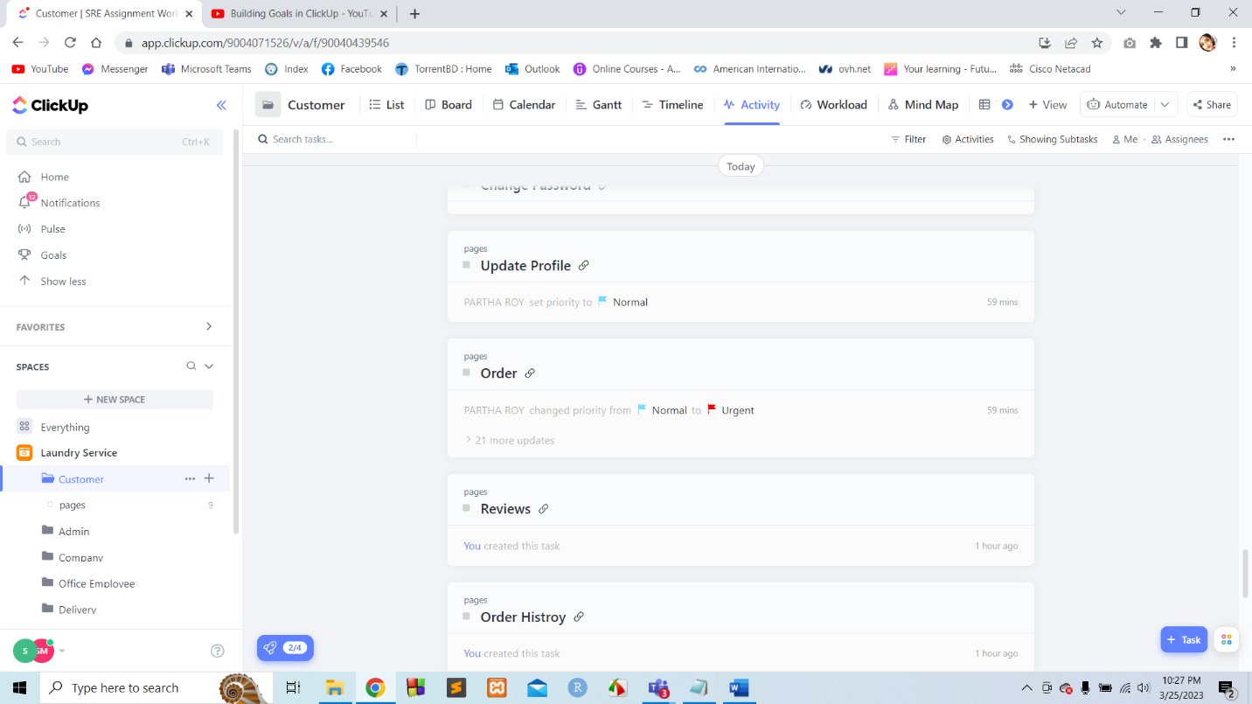

**Figure: The overall total Activity for the Space (Laundry Service).**

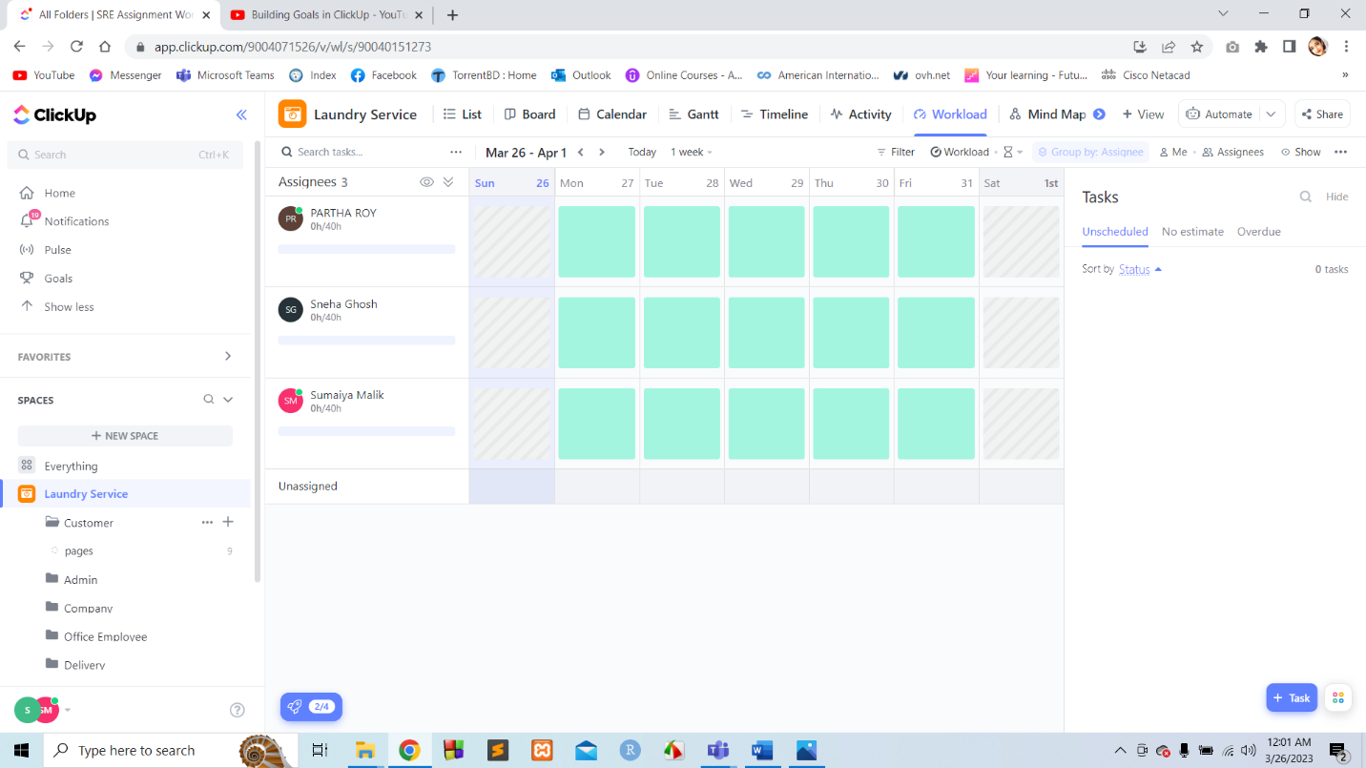

**Figure: The overall total Workload (1st Week) for the Space for group members (Laundry Service).**

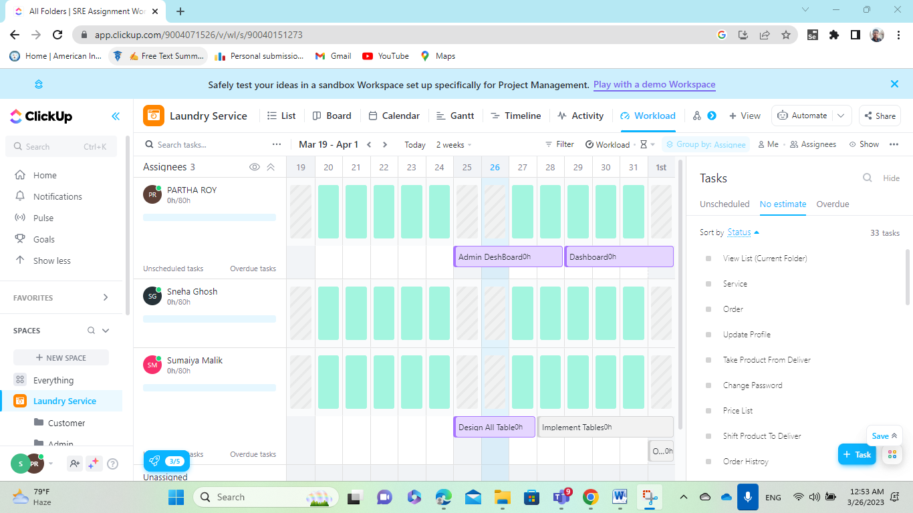

**Figure: The overall total Workload (2nd Week) for the Space for group members (Laundry Service).**

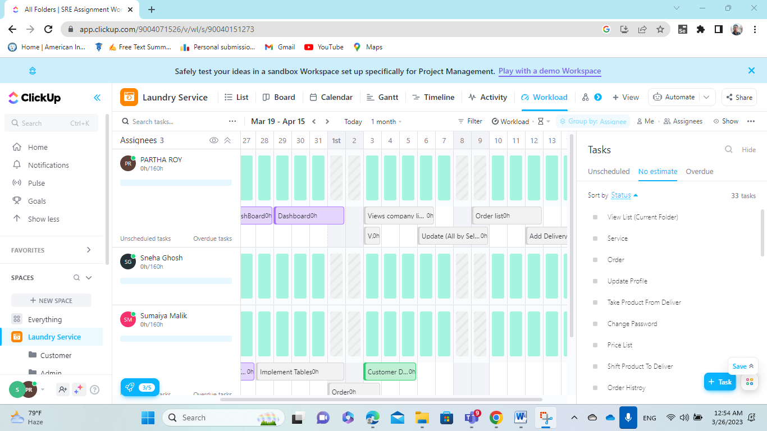

**Figure: The overall total Workload (1month) for the Space for group members (Laundry Service)**

**Set Goals Steps:**

|  |  |
| --- | --- |
| **Figure: Set goal name** | **Figure: Assign Owner for the goal** |
| **Figure: Set TimeLine for the goal** | **Figure: Goal for 1st week** |

**Figure: All Steps to create a Goal**

**Set A Target for Goal Steps:**

|  |  |
| --- | --- |
| **Figure: Set Target name** | **Figure: Assign Owner for the Target** |
| **Figure: Add task** | **Figure: Set a target for 1st week Goal** |

**Figure: All Steps to create a Target**

**1st Week Goals:**

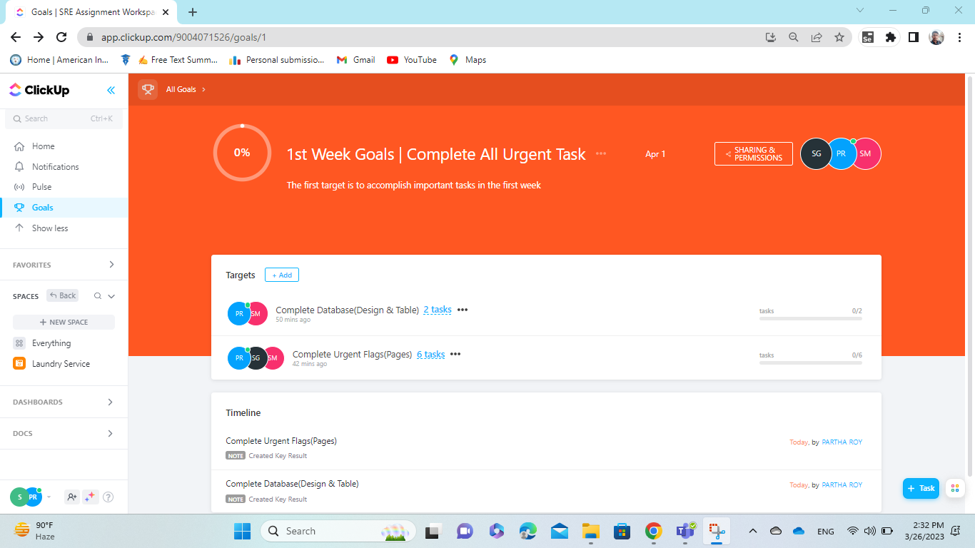

**Figure: A complete goal (1st week goal) with 2 target and assign task**

**Update Status OR Change task status:**

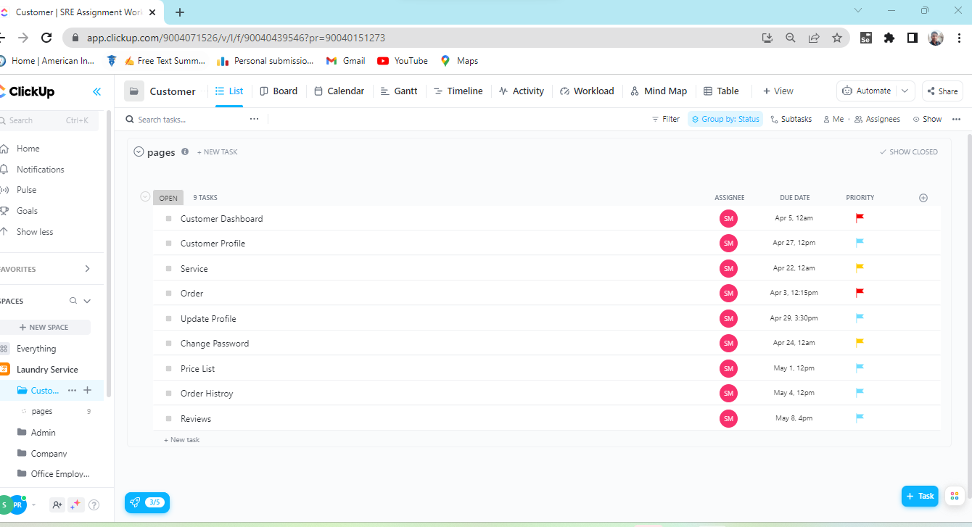

**Figure: Before Change task status in Customer**

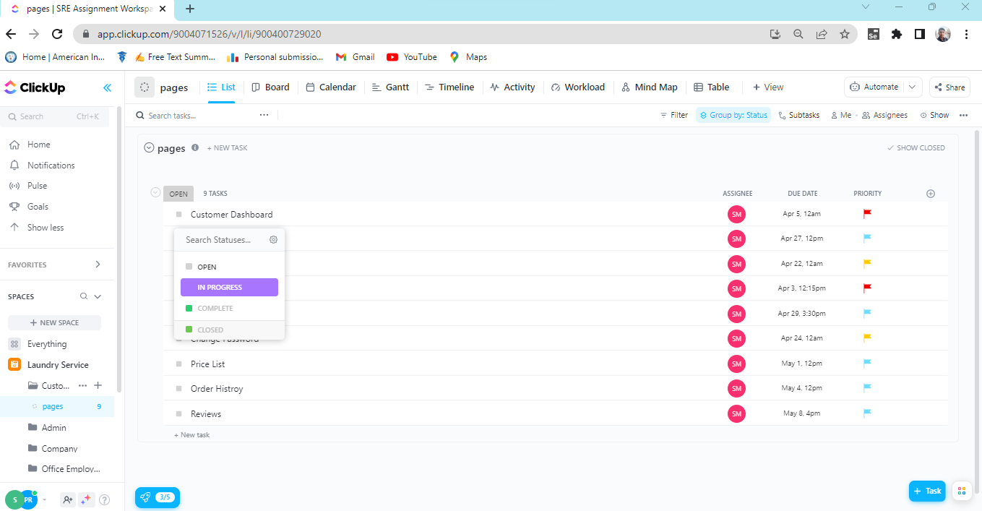

**Figure: Changing task status from in Customer list**

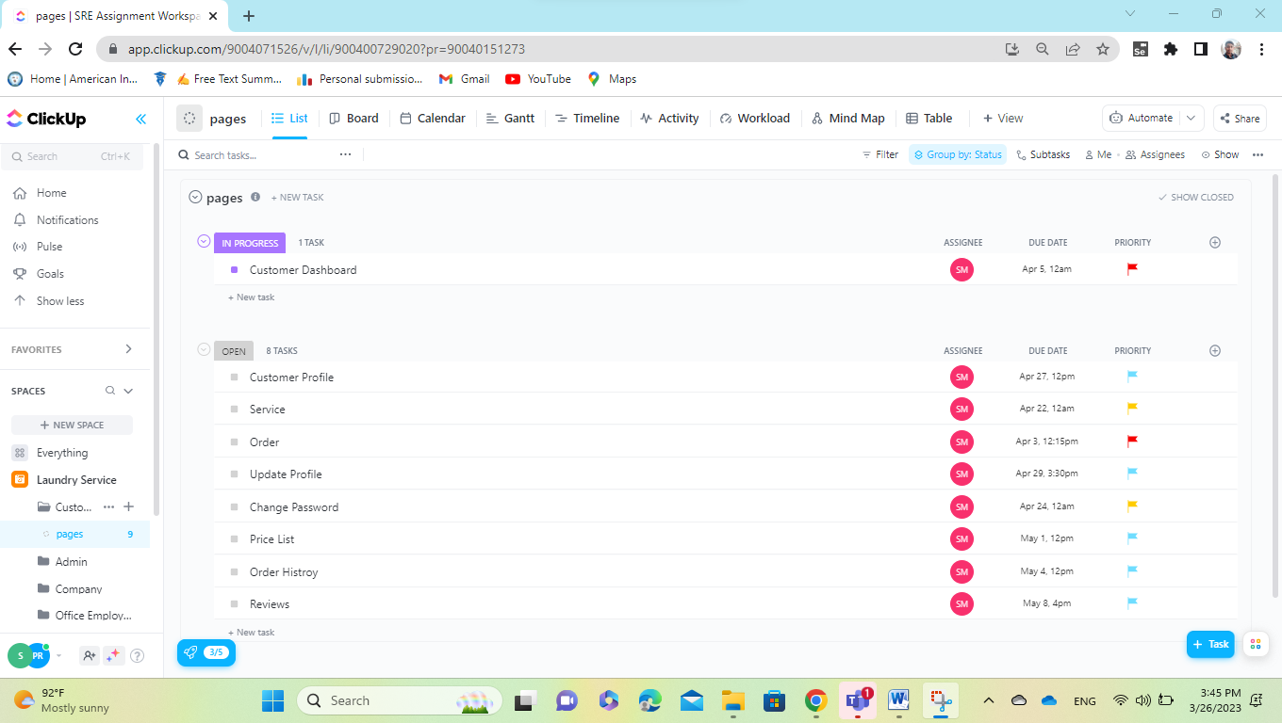

**Figure: After Change task status in Customer**

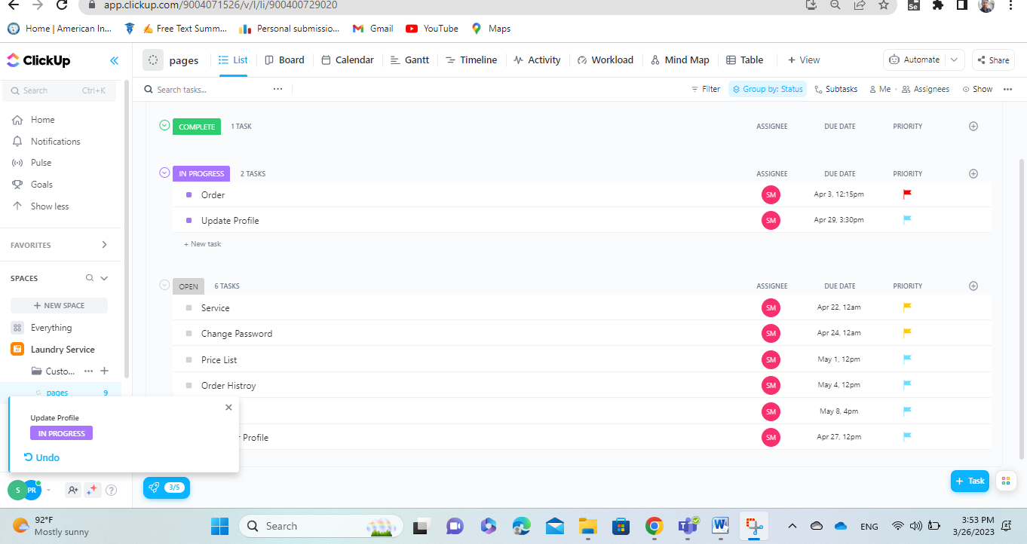

**Figure: After Change task status in Customer**

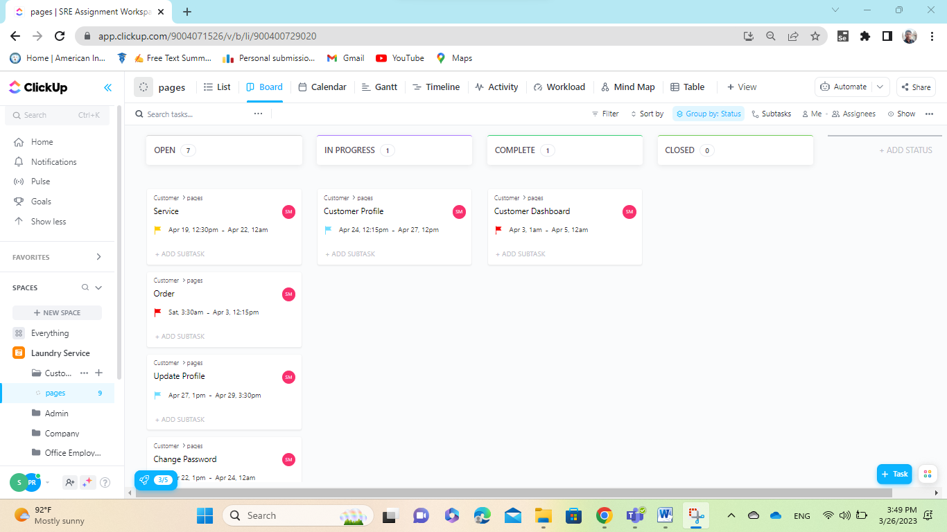

**Figure: Board After Change task status**

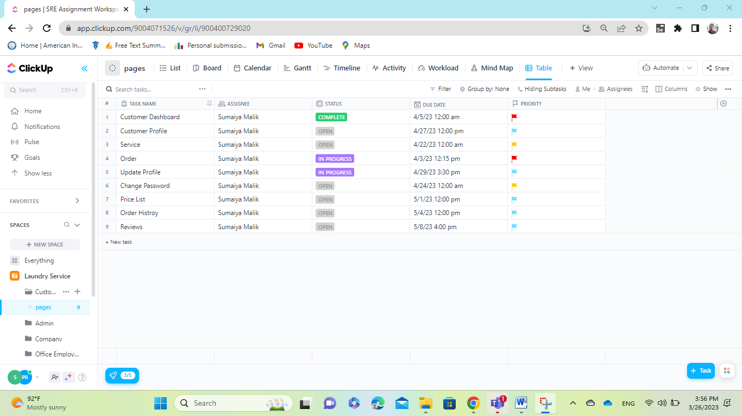

**Figure: Table After Change task status.**

**Chat Or Comment:**

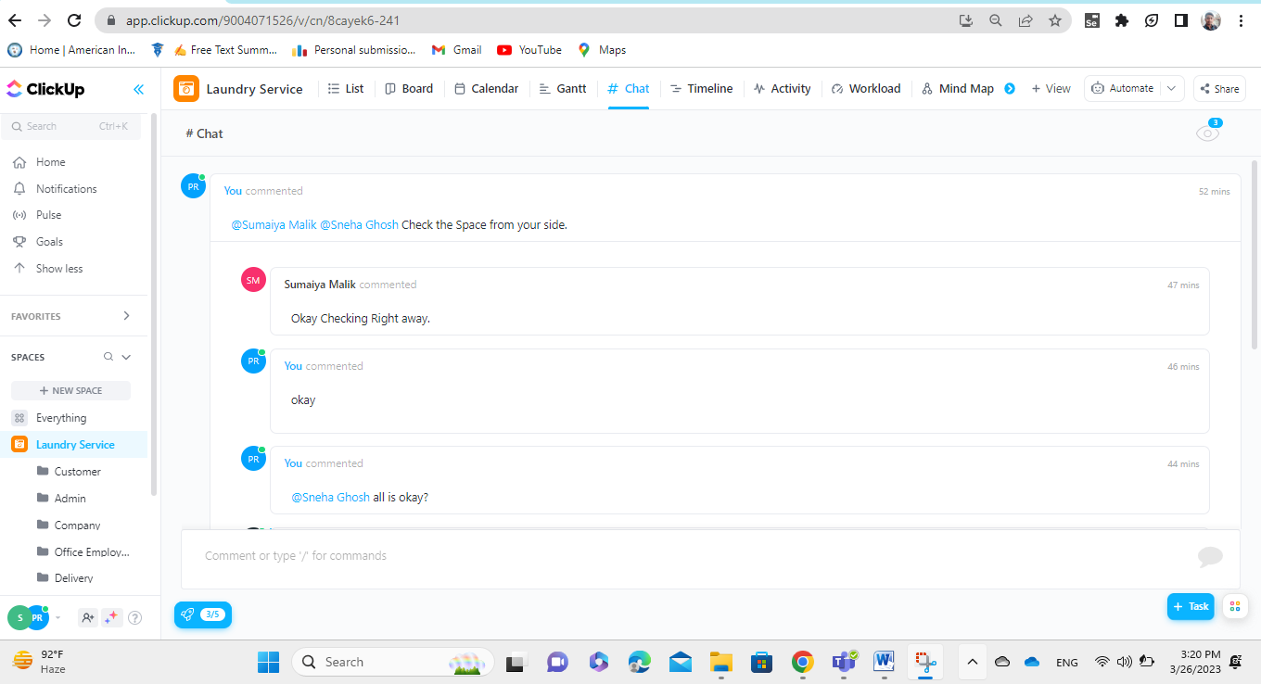

**Figure: Chat during working hours.**

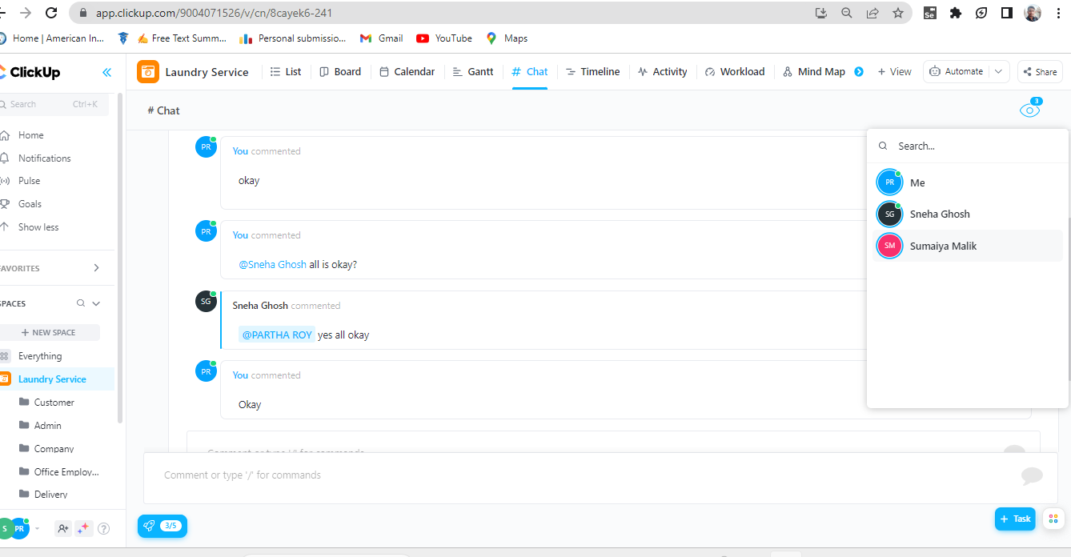

**Figure: Chat during working hours.**

**Notification and Alert By Email:**

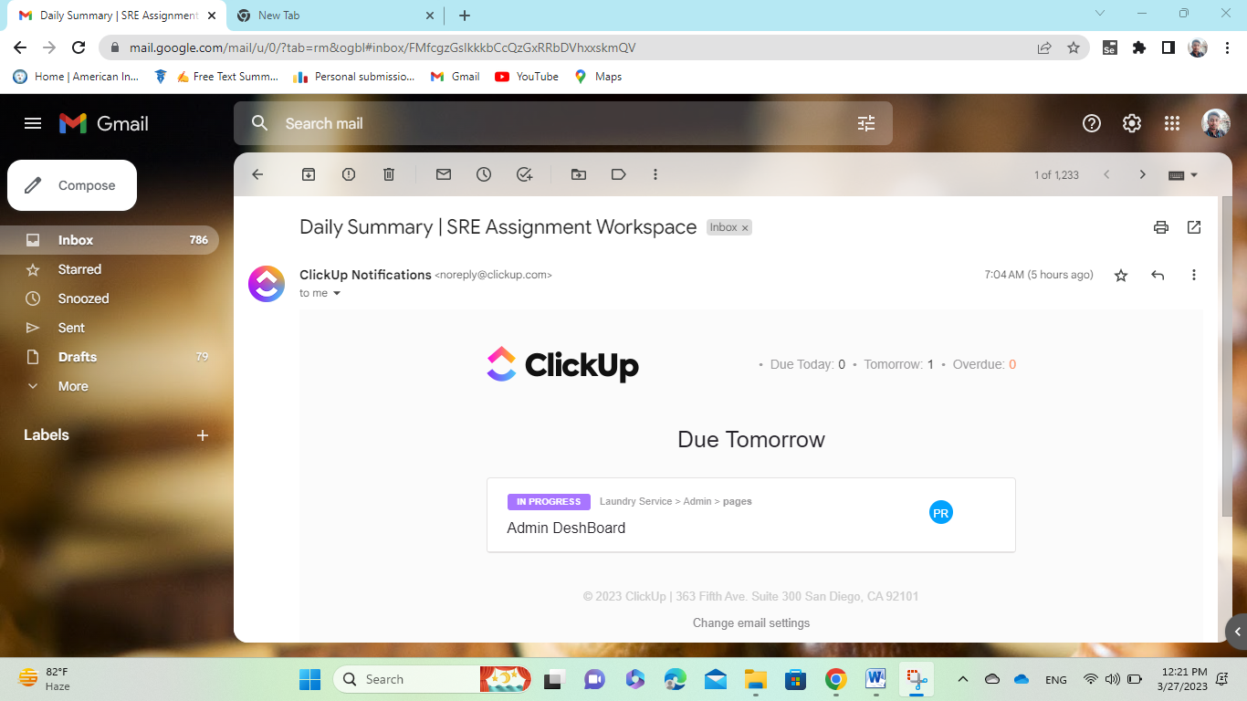

**Figure: Notification by Email**

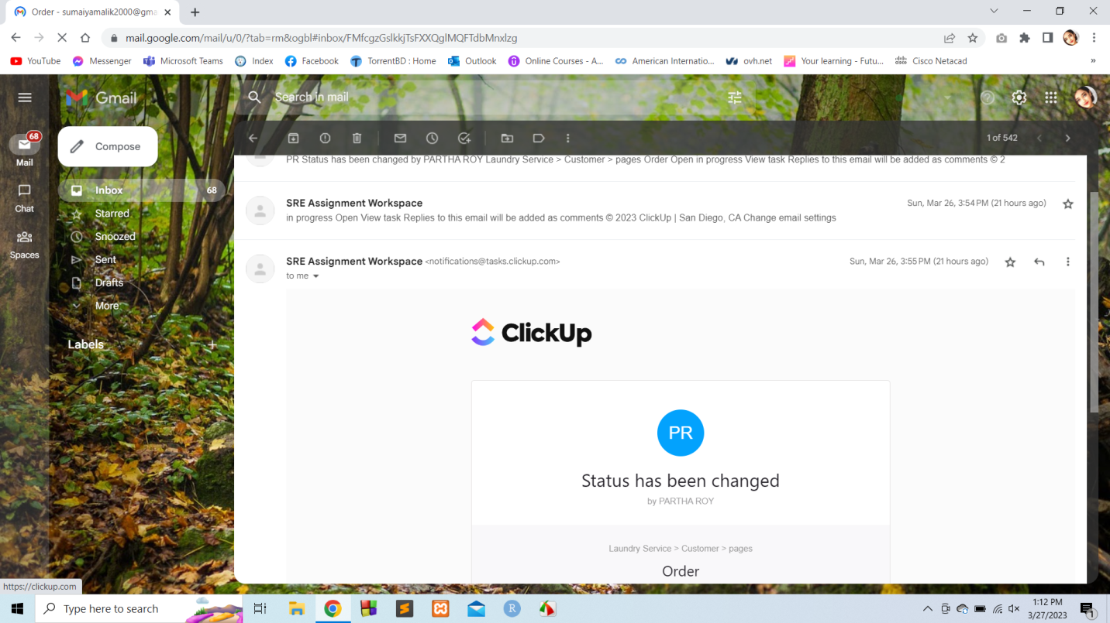

**Figure: Notification by Email**

**White Board:**

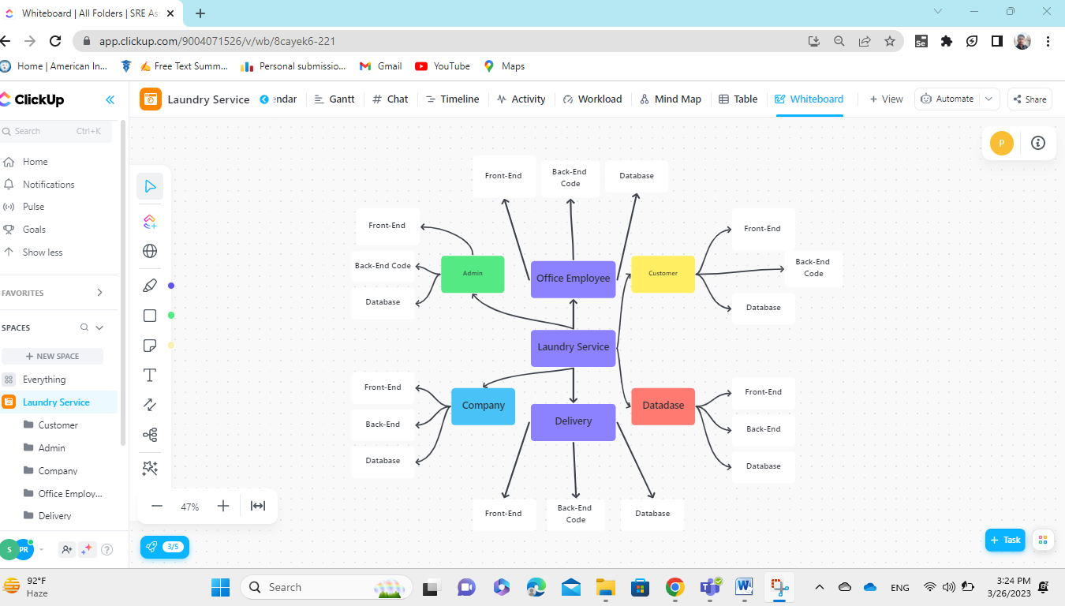

**Figure: Basic design diagram for Work Space.**